**NAME – KHUSHI PANWAR**

**ROLL NO – 2021334**

**Course – Bsc. Computer Science, 1st Year**

**C++ Additional Practical Questions**

1. **WAP to print “Hello world”:**

#include <iostream>

using namespace std;

int main()

{

    cout << "Hello world!" << endl;

    return 0;

}

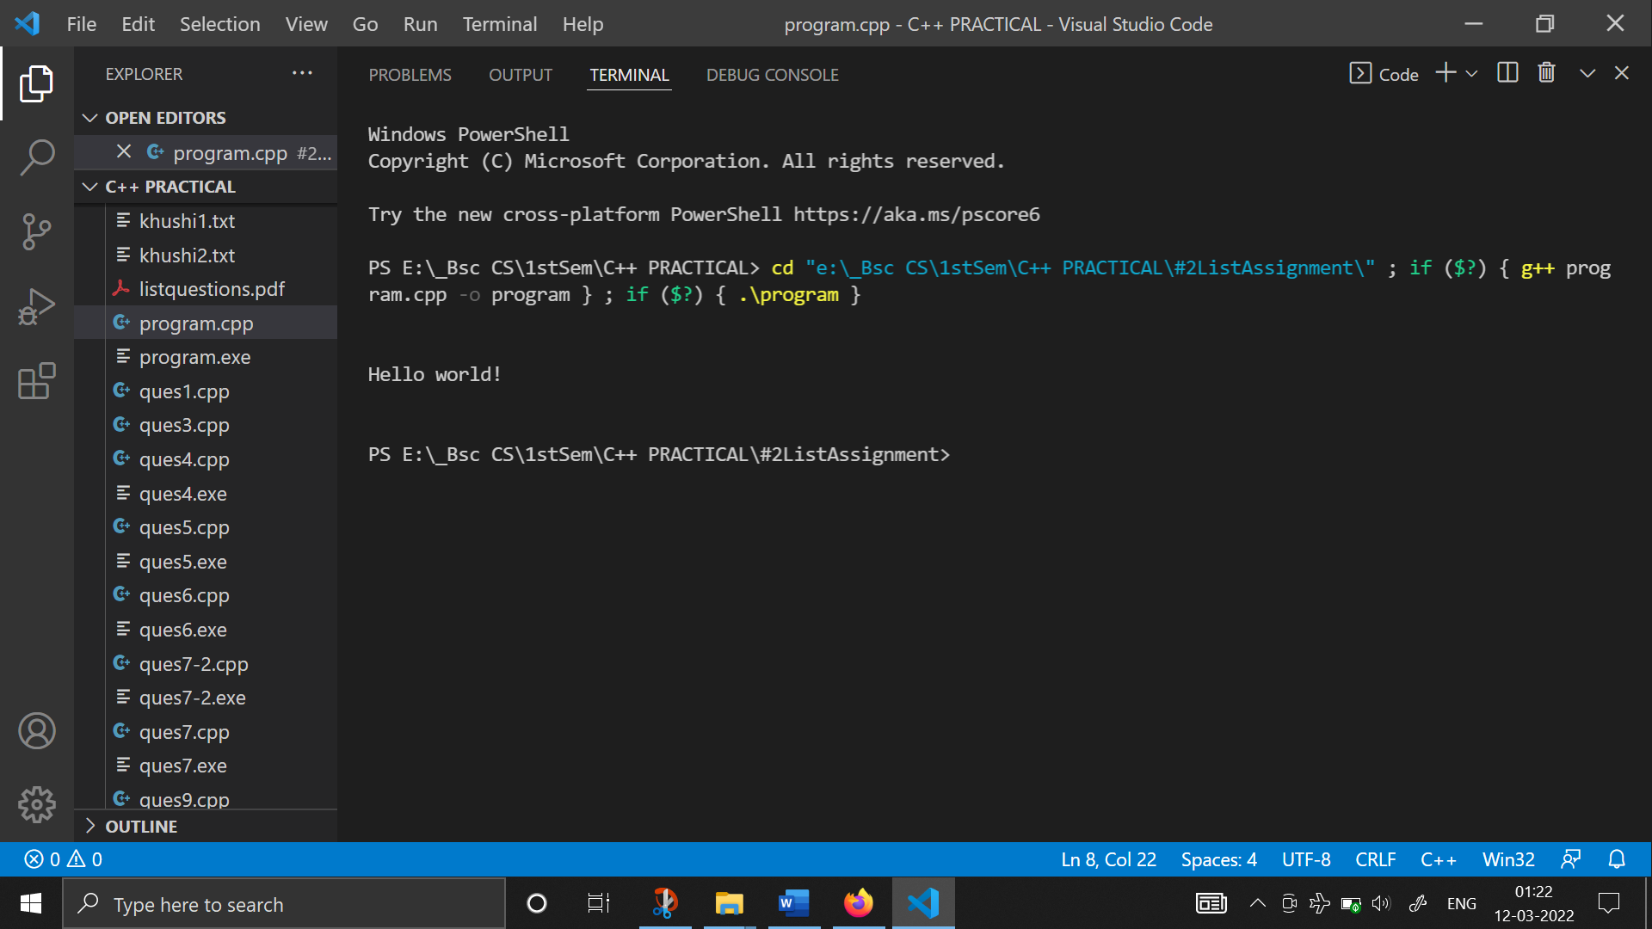

1. **WAP to perform arithmetic operations on the numbers input by the user:**

#include <iostream>

using namespace std;

float sum(float x, float y)

{

    return x * y;

}

float diff(float x, float y)

{

    return x - y;

}

float prod(float x, float y)

{

    return x * y;

}

float divd(float x, float y)

{

    return x / y;

}

int main()

{

    cout << endl

         << endl;

    cout << "\t ** Perform arithmetic operation on the numbers input by the user** "<<endl<<endl;

                  float num1,

        num2, add, sub, mul, div;

    cout << "Enter first number : " << endl;

    cin >> num1;

    cout << "Enter second number: " << endl;

    cin >> num2;

    cout << "\nThe first number is " << num1 << endl;

    cout << "The second number is " << num2 << endl;

    add = sum(num1, num2);

    sub = diff(num1, num2);

    mul = prod(num1, num2);

    div = divd(num1, num2);

    cout << "\nThe ADDITION result is " << add << endl;

    cout << "The SUBTRACTION result is " << sub << endl;

    cout << "The MULTIPLICATION result is " << mul << endl;

    cout << "The DIVISION result is " << div << endl;

}

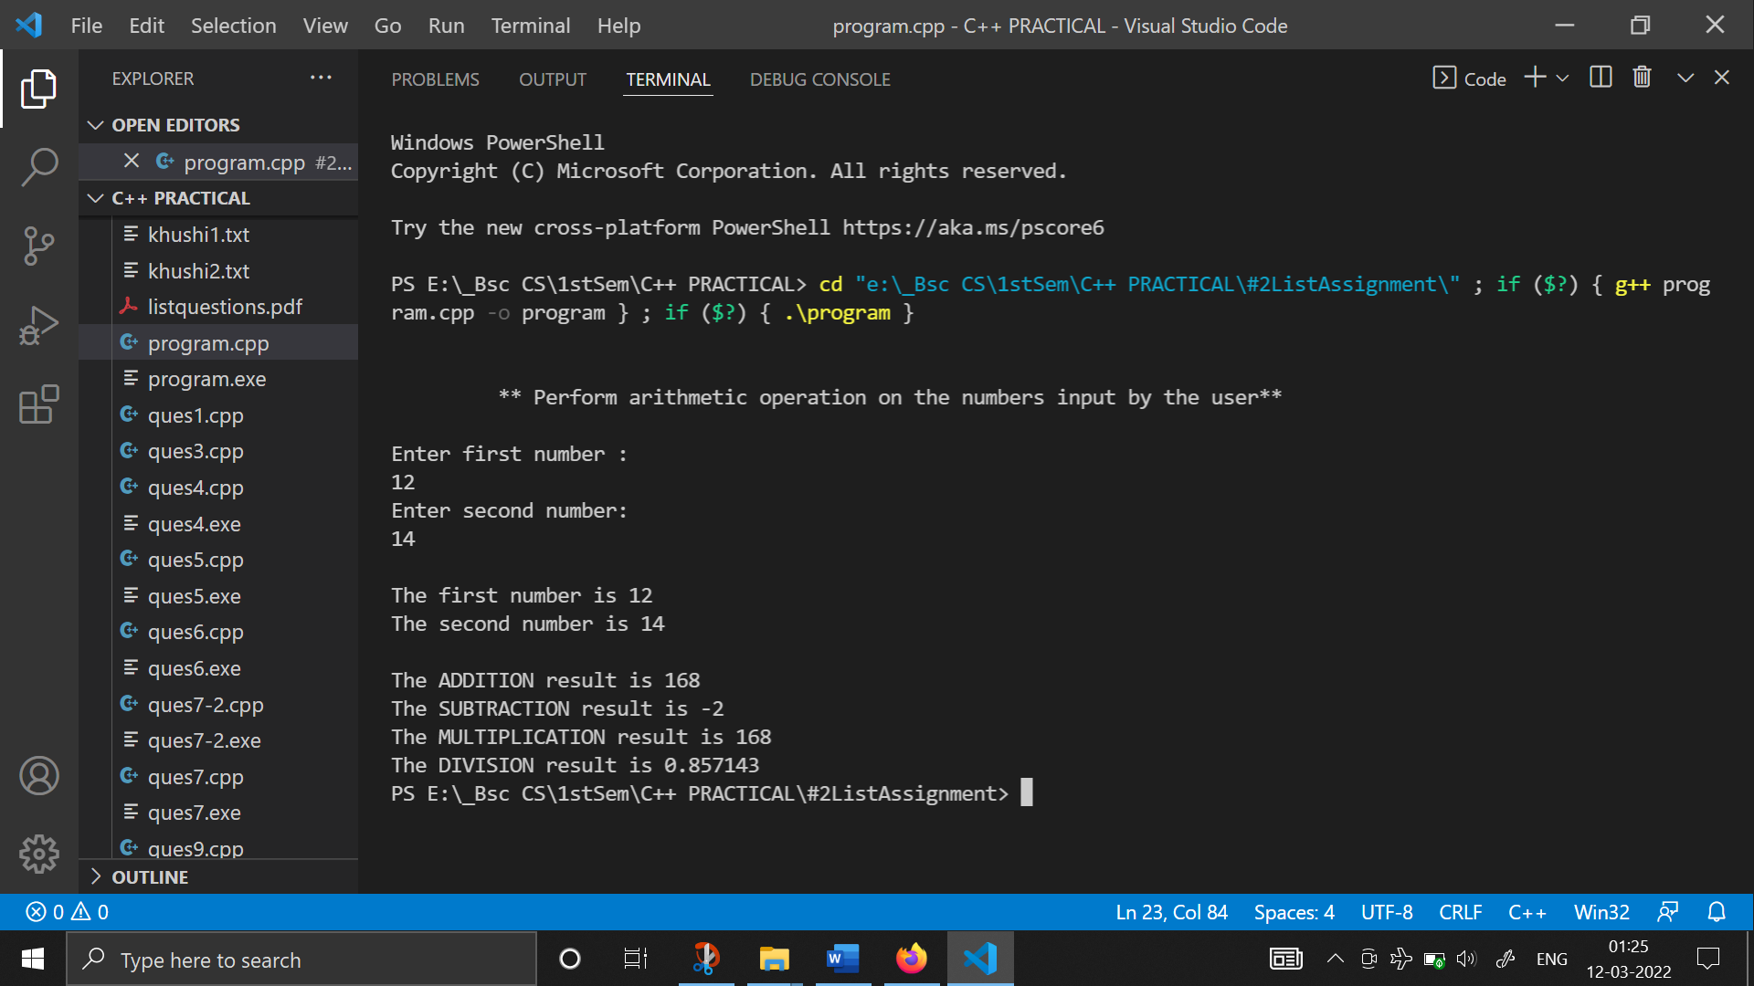

1. **WAP that displays the size of data type and different data values stored in a variable :**

#include <iostream>

using namespace std;

int main()

{

    cout<<endl<<endl;

    cout << "This Program shows the Size of different DATA TYPES supported in C++" << endl;

    cout << "Also different values have been assigned to the variables" << endl;

    int x;

    unsigned int x2;

    short y;

    long z;

    cout << "Size of int x = " << sizeof(x) << endl;

    cout << "Size of unsigned x2 = " << sizeof(x) << endl;

    cout << "Size of short y = " << sizeof(y) << endl;

    cout << "Size of long z = " << sizeof(z) << endl;

    x = -23456789;

    x2 = 12;

    y = 2323;

    z = 123456789;

    cout << "\nint: x = " << x << endl;

    cout << "unsigned: x2 = " << x2 << endl;

    cout << "short: y = " << y << endl;

    cout << "long: z = " << z << endl;

    float a;

    double b;

    long double c;

    cout << "Size of float a = " << sizeof(a) << endl;

    cout << "Size of double b = " << sizeof(b) << endl;

    cout << "Size of long double c = " << sizeof(c) << endl;

    a = -34.12345;

    b = 2323.2323;

    c = 2300.2323;

    cout << "\nfloat: a = " << a << endl;

    cout << "double: b = " << b << endl;

    cout << "long double: c = " << c << endl;

    cout << endl;

    bool p, q;

    cout << "Size of bool p = " << sizeof(p) << endl;

    cout << "Size of bool q = " << sizeof(q) << endl;

    p = true;

    q = false;

    cout << "\nBool: p = " << p << endl;

    cout << "Bool : q = " << q << endl;

    char ch;

    cout << "Size of char ch = " << sizeof(char) << endl;

    ch = 'a';

    cout << "\nChar ch = " << ch << endl;

    return 0;

}

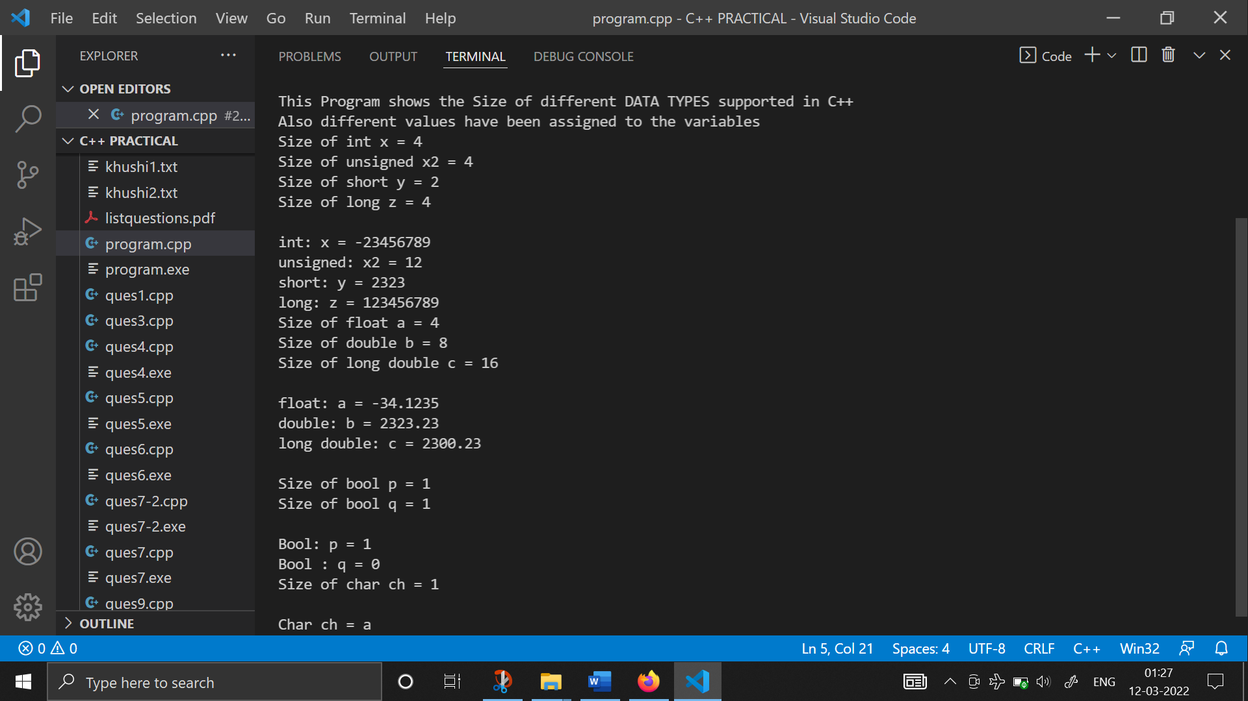

1. **WAP to print ASCII code of a character input by the user, from A to Z.**

#include <iostream>

using namespace std;

int main()

{

    cout<<endl<<endl;

    cout<<"\t ** PRINT ASCII CODE OF THE CHARACTER **"<<endl<<endl;

    char ch1, ch;

    cout << "Enter any character here: ";

    cin >> ch;

    cout << "\nThe entered character is " << ch << endl;

    cout << "The ASCII Code of " << ch1 << " is " << (int)ch << endl;

    cout << "The Alphabets & their ASCII Values from A to Z are " << endl;

    ch = 'A';

    while (ch <= 'Z')

    {

        cout << ch << " : ASCII CODE = " << (int)ch << endl;

        ch = ch + 1;

    }

    return 0;

}

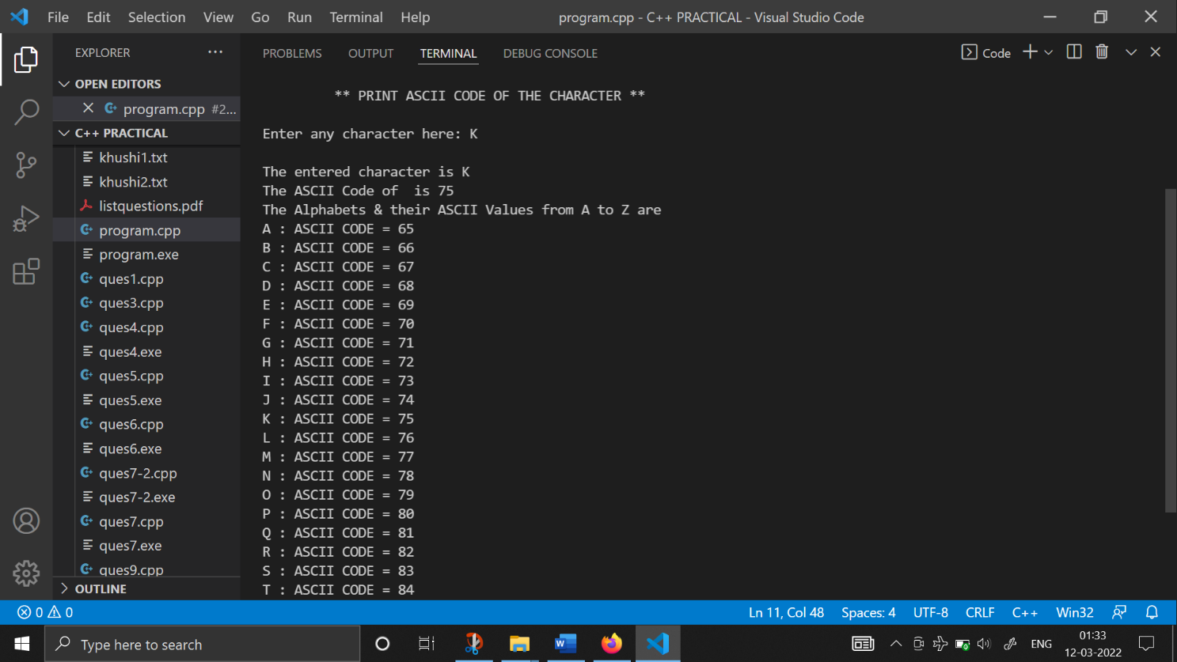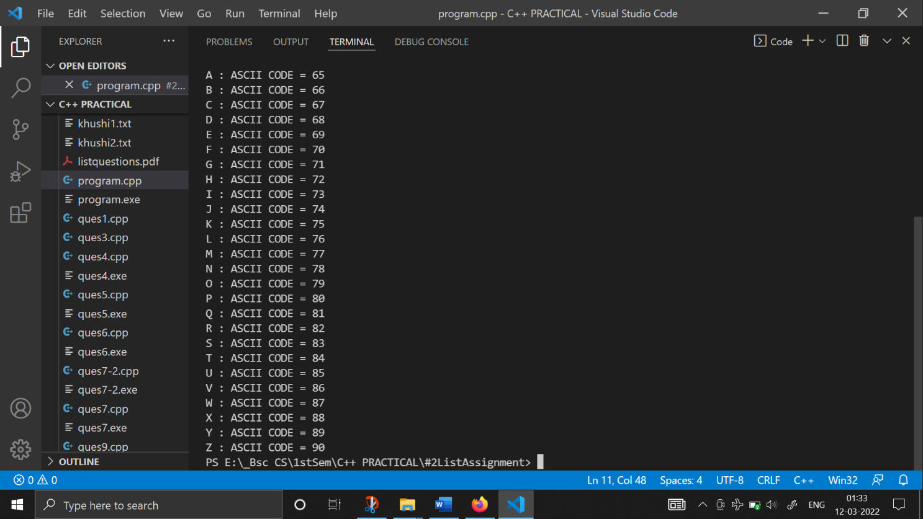

1. **WAP to display factorial of a number entered by the user :**

#include <iostream>

using namespace std;

int main()

{

    int num;

    cout << "\t THIS PROGRAM FINDS THE FACTORIAL OF A GIVEN NUMBER" << endl;

    cout << "Enter the number here : ";

    cin >> num;

    int fact = 1;

    int i = 1;

    while (i <= num)

    {

        fact = fact * i;

        i = i + 1;

    }

    cout << "The factorial of " << num << " is " << fact << endl;

    return 0;

}

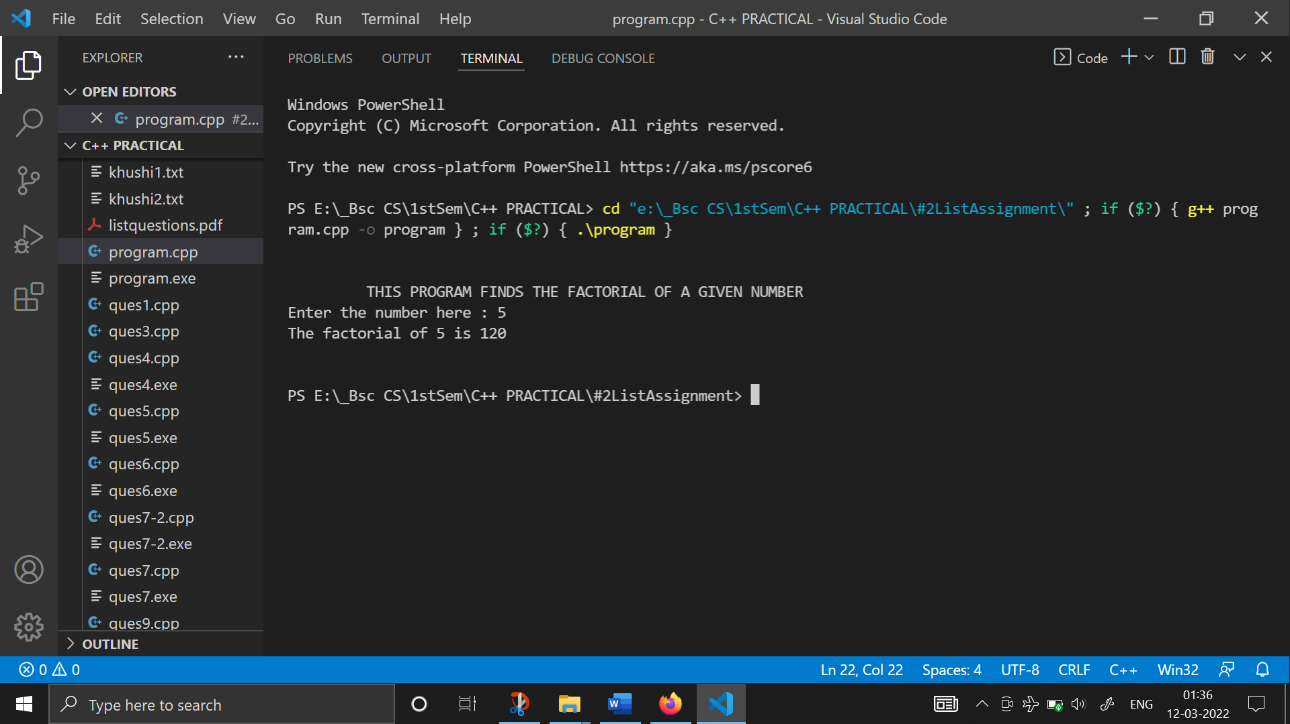

1. **WAP to demonstrate the use of set width manipulator:**

#include <iostream>

#include <iomanip>

using namespace std;

int main()

{

    int d123 = 123;

    float f123 = 1.23;

    char chA = 'A';

    cout << "Demonstrate set width manipulator\n";

    cout << "0...0....1....1" << endl;

    cout << "1...5....0....5" << endl;

    cout << d123 << f123 << chA << "\t |no width" << endl;

    cout << setw(1) << d123 << setw(1) << f123 << setw(1) << chA << "\t |Width too small" << endl;

    cout << setw(5) << d123 << setw(5) << f123 << setw(5) << chA << "\t |Width 5 space each" << endl;

    cout << setw(10) << "Hello"

         << "\t |String Width 10" << endl;

    cout << setw(3) << "Hello"

         << "\t\t |String width 3" << endl;

    return 0;

}

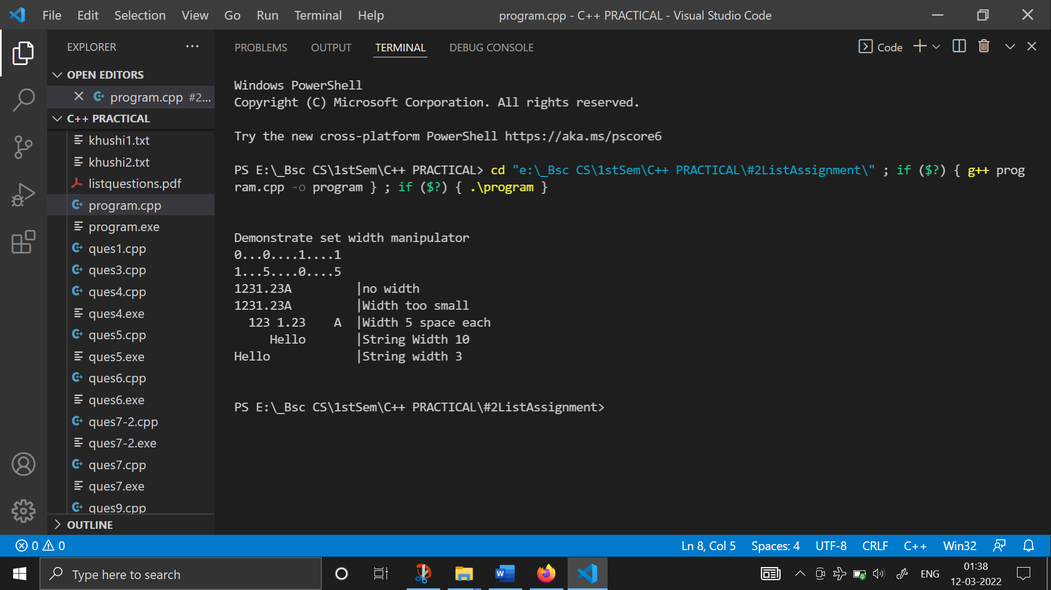

1. **WAP for demonstrating the use of fill character :**

#include <iostream>

#include <iomanip>

using namespace std;

int main()

{

    float amount = 123.45;

    cout << "\tDemonstrate fill characters\n"

         << endl;

    cout << setw(10) << amount << "\tAmount with space fill\n";

    cout << setw(10) << setfill('*') << amount << "\tAmount with check protection fill\n";

    cout << setw(10) << setfill(' ') << amount

         << "\tand again with sapce fill\n";

    return 0;

}

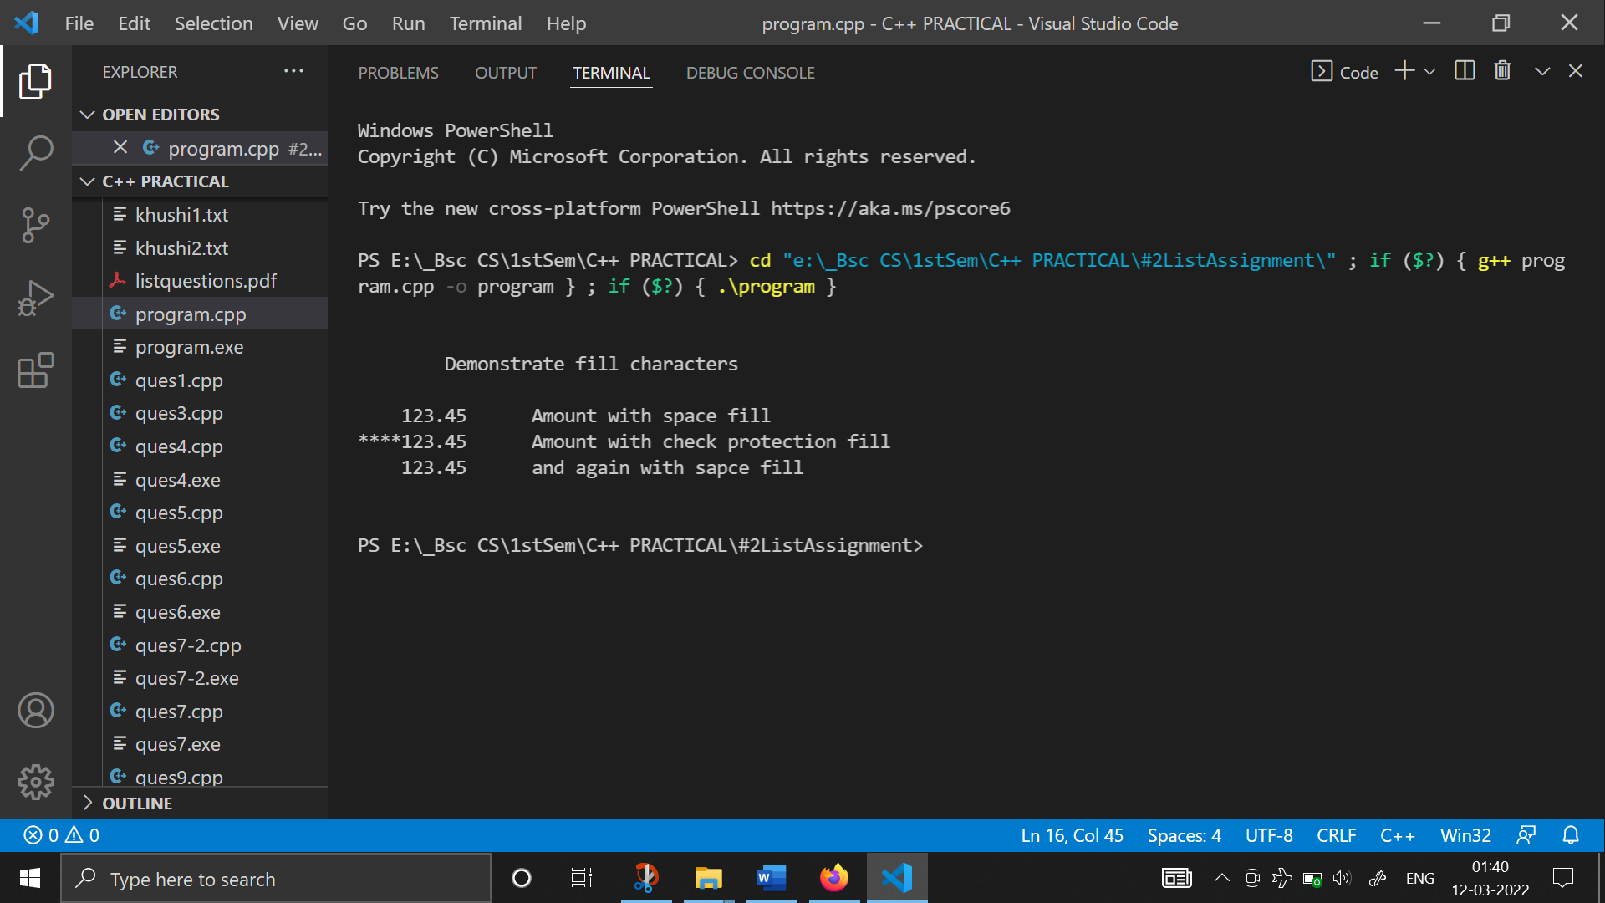

1. **WAP for demonstrating the numeric manipulators :**

#include <iostream>

#include <iomanip>

using namespace std;

int main()

{

    cout << endl

         << endl;

    int a = 1234;

    cout << "Value in decimal: \t" << endl;

    cout << setw(5) << a << endl;

    cout << "Value in hexadecimal: \t";

    cout << hex;

    cout << setw(5) << a << endl;

    cout << "Value in Octal: \t";

    cout << oct;

    cout << setw(5) << a << endl;

    cout << "Value in decimal: \t";

    cout << dec;

    cout << setw(5) << a << endl;

    cout << endl

         << endl;

    return 0;

}

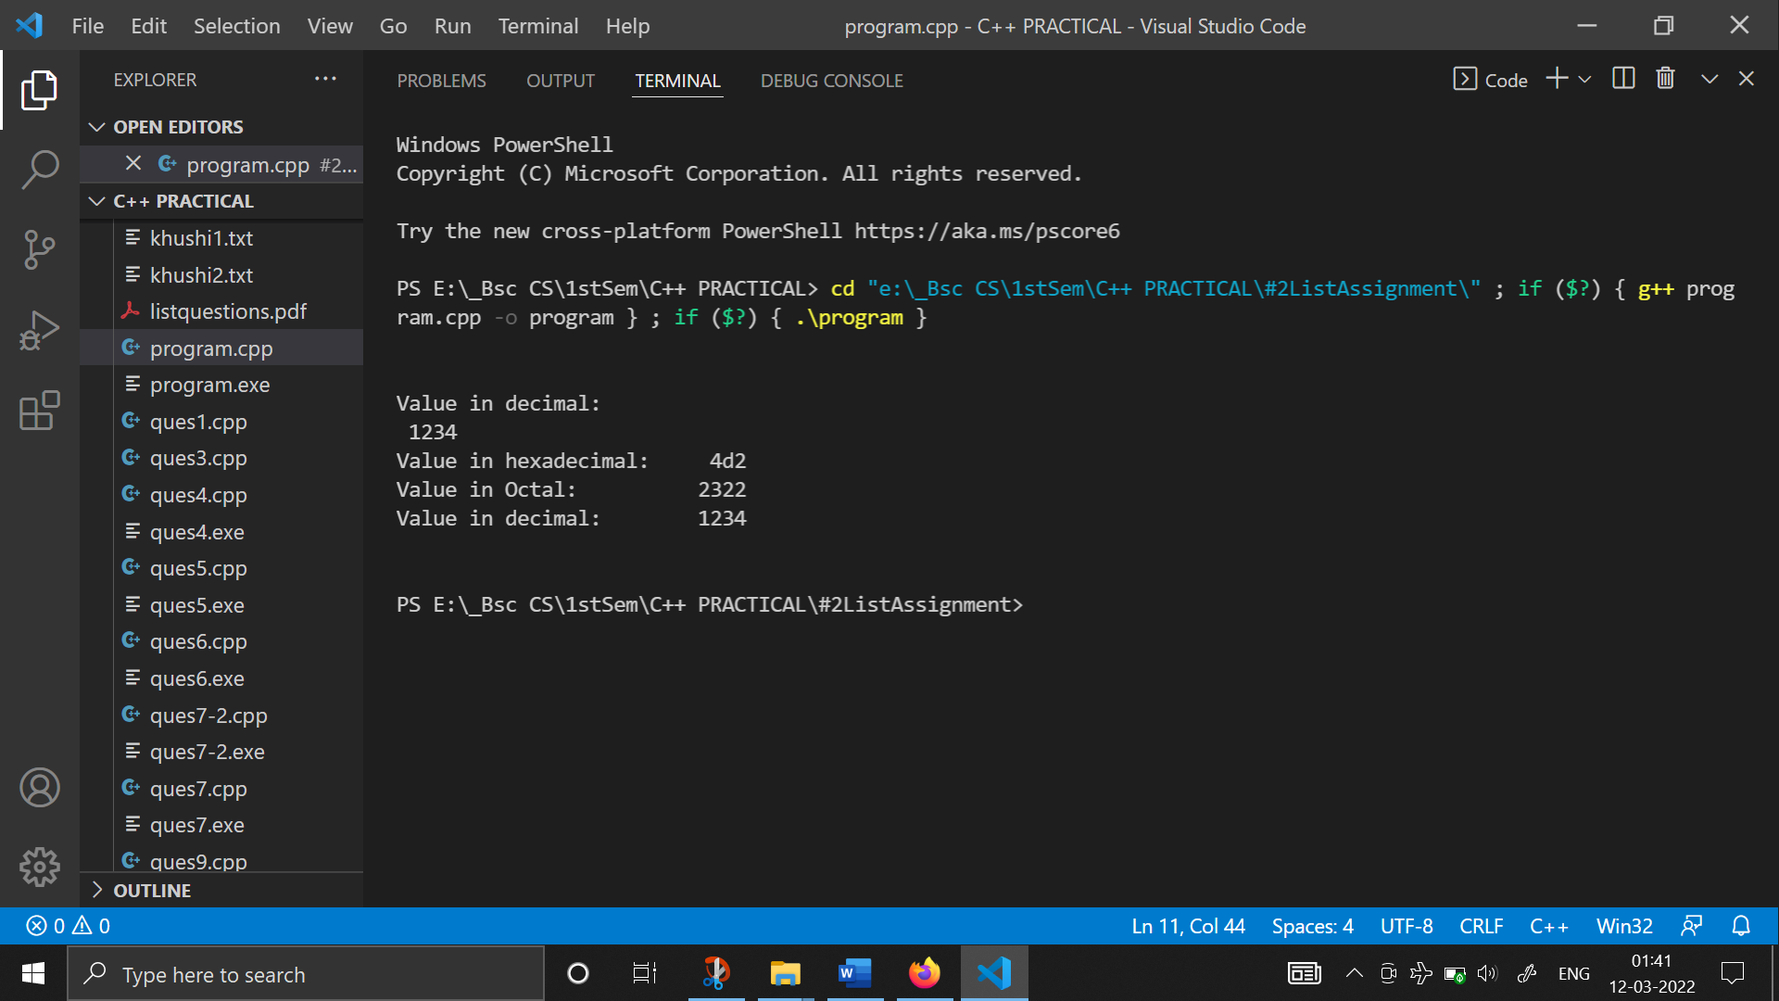

1. **WAP for demonstrating the float manipulators :**

#include <iostream>

#include <iomanip>

using namespace std;

int main()

{

    cout<< "Demonstrate float manipulators\n"<<endl;

    float f1=1.0;

    float f2=1.234;

    float f3=1234567.876;

    cout<< f1 <<"\t\tWith no manipultors\n";

    cout<< f2 <<endl;

    cout<< f3 <<endl<<endl;

    cout<< fixed;

    cout<< f1 <<"\tWith fixed added\n";

    cout<< f2<<endl;

    cout<< f3<<endl<<endl;

    cout<< setprecision(2);

    cout<< f1 <<"\t\tWith no setprecision added\n";

    cout<< f2 <<endl;

    cout<< f3 <<endl<<endl;

    cout<< setprecision(0);

    cout<< f2 <<"\t\tWith no setprecision added\n"<<endl;

    cout<< setprecision(0)<<showpoint

        << f2 <<"\t\tWith showpoint\n";

    return 0;

}

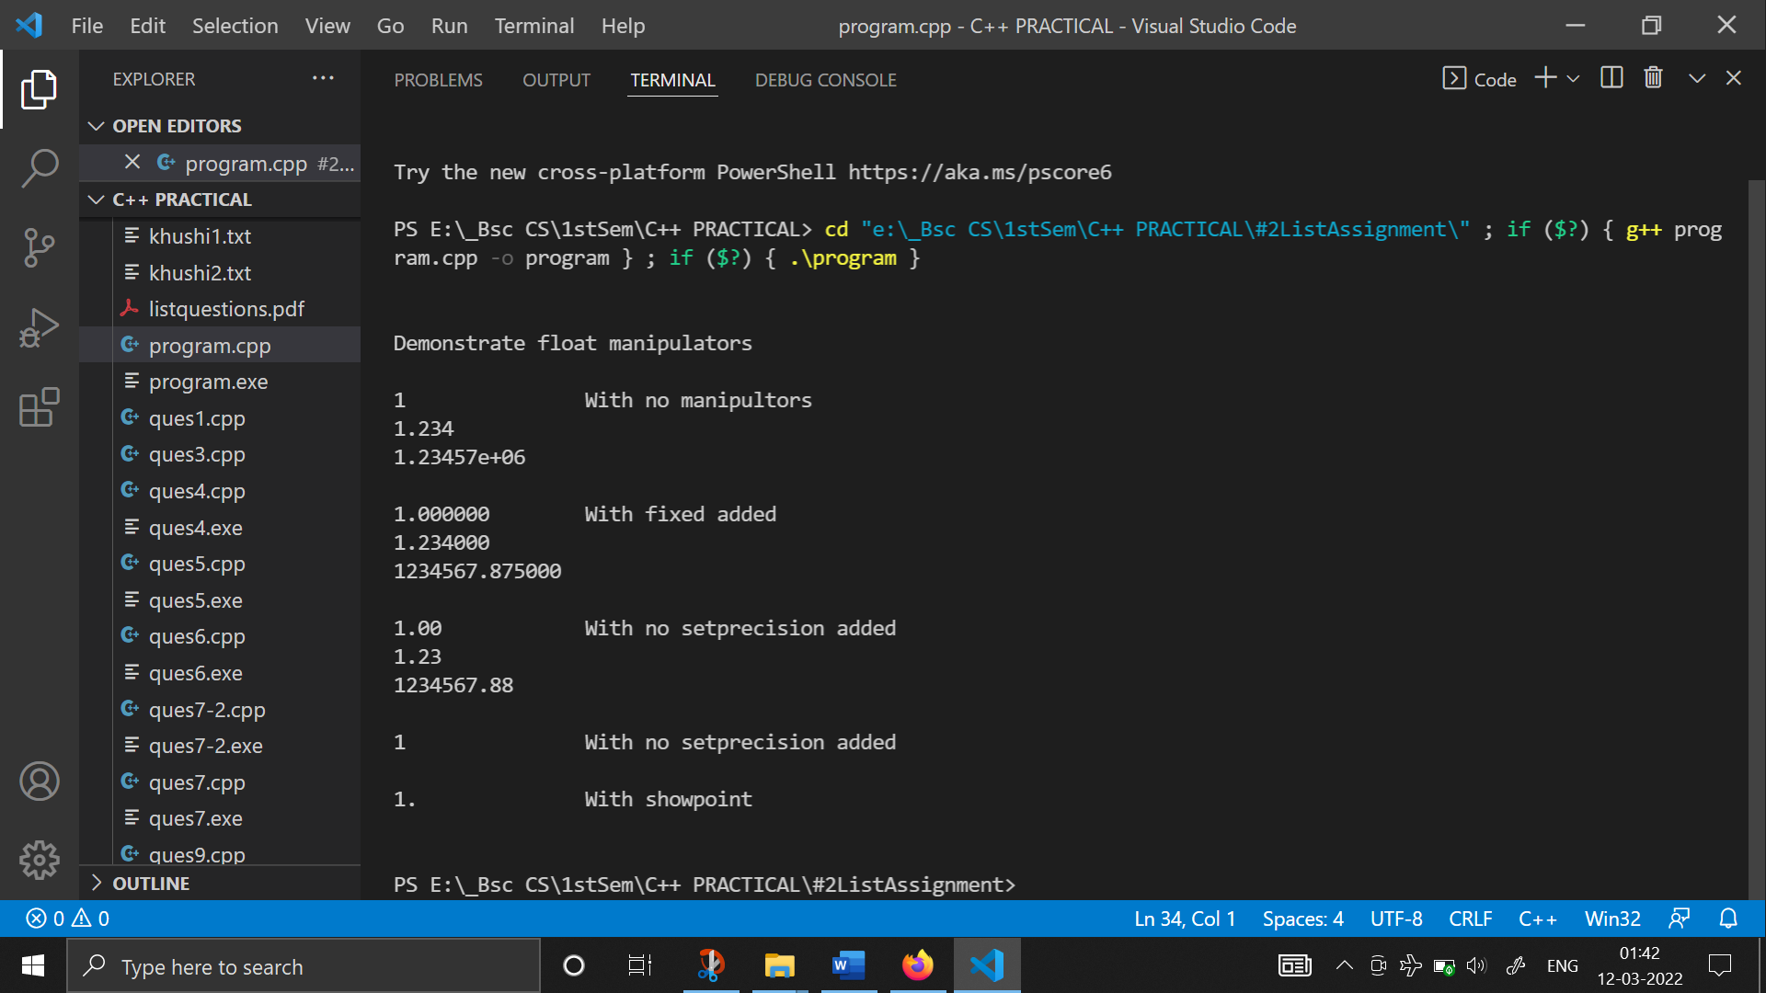

1. **WAP on extraction operators :**

#include <iostream>

#include <iomanip>

using namespace std;

int main()

{

    char aChar;

    int integer;

    float dlAmnt;

    cout<<"Please enter an integer, "

        <<"a dollar amount and a character.\n";

    cin>>integer>>dlAmnt>>aChar;

    cout<< "\nThank you. You entered:\n";

    cout<< setw(6)<<integer<<" "

        << setfill('*')<<setprecision(2)<<fixed

        << '$' <<setw(10)<<dlAmnt

        << setfill(' ')<<setw(3)<<aChar<<endl;

    return 0;

}

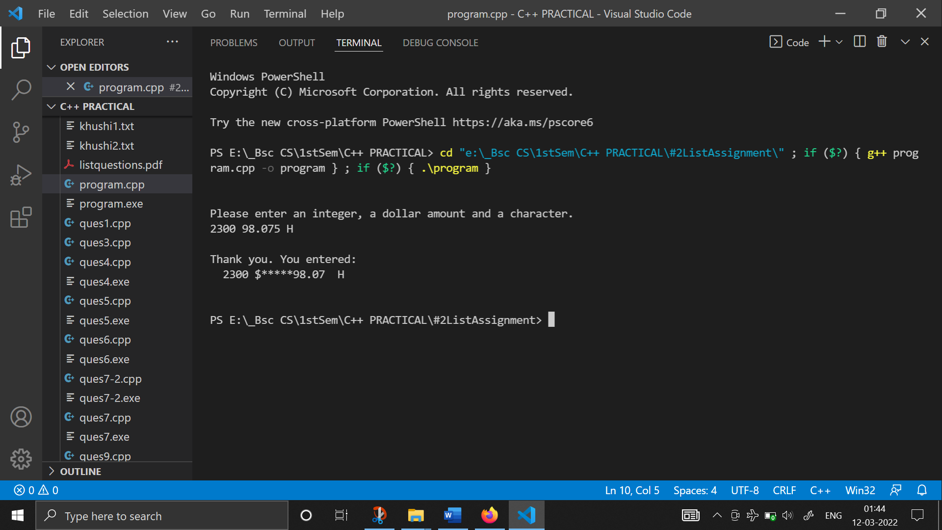

1. **Program to calculate the area and circumference of a circle :**

#include <iostream>

#include <iomanip>

using namespace std;

int main()

{

    float pie = 3.1416;

    float circ;

    float area;

    float radius;

    cout << "\nPlease Enter the value of the radius : ";

    cin >> radius;

    circ = 2 * pie * radius;

    area = pie * radius * radius;

    cout << "\nRdaius is:        " << radius;

    cout << "\nCircumference is: " << circ;

    cout << "\nArea is:          " << area;

    return 0;

}

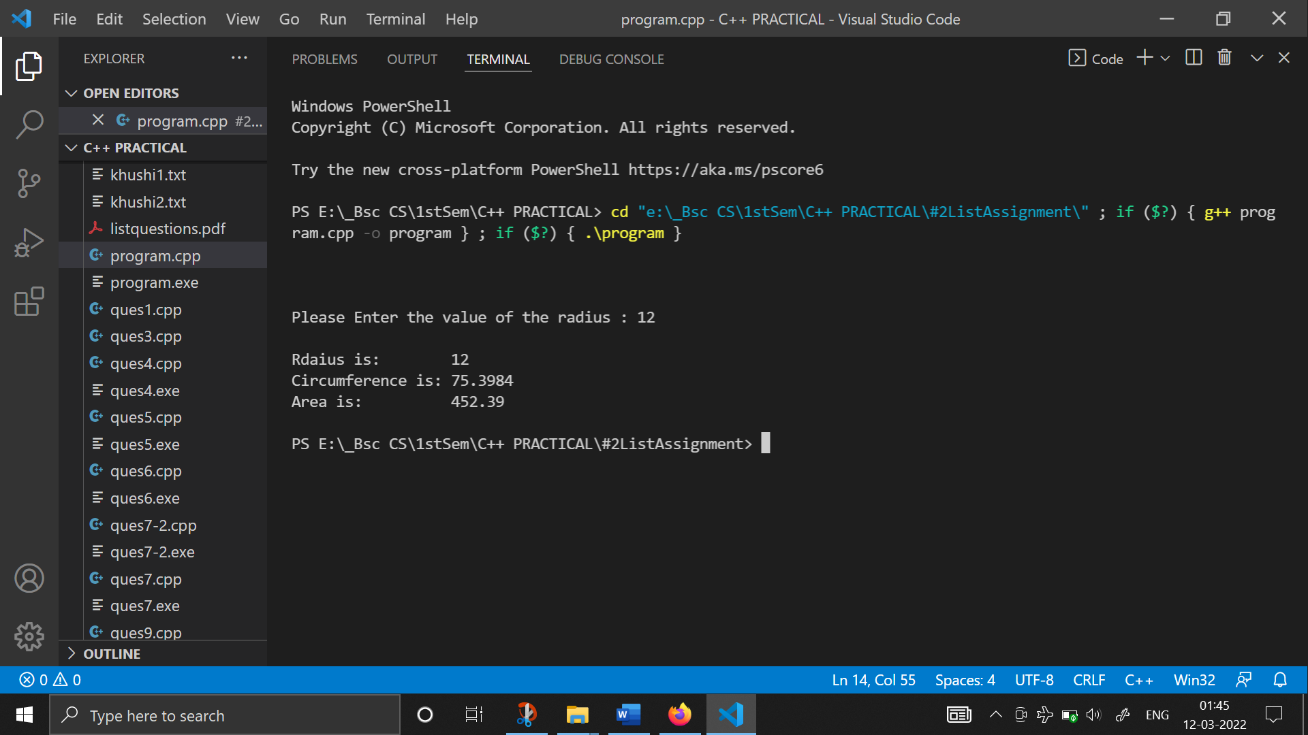

1. **WAP to demonstrate the prefix increment :**

#include <iostream>

#include <iomanip>

using namespace std;

int main()

{

   int a=5;

    cout<< "Value of a     :"<< setw(2)<< a <<endl;

    cout<< "Value of ++a   :"<< setw(2)<< ++a <<endl;

    cout<< "New Value of a :"<< setw(2)<< a<<endl;

    return 0;

}

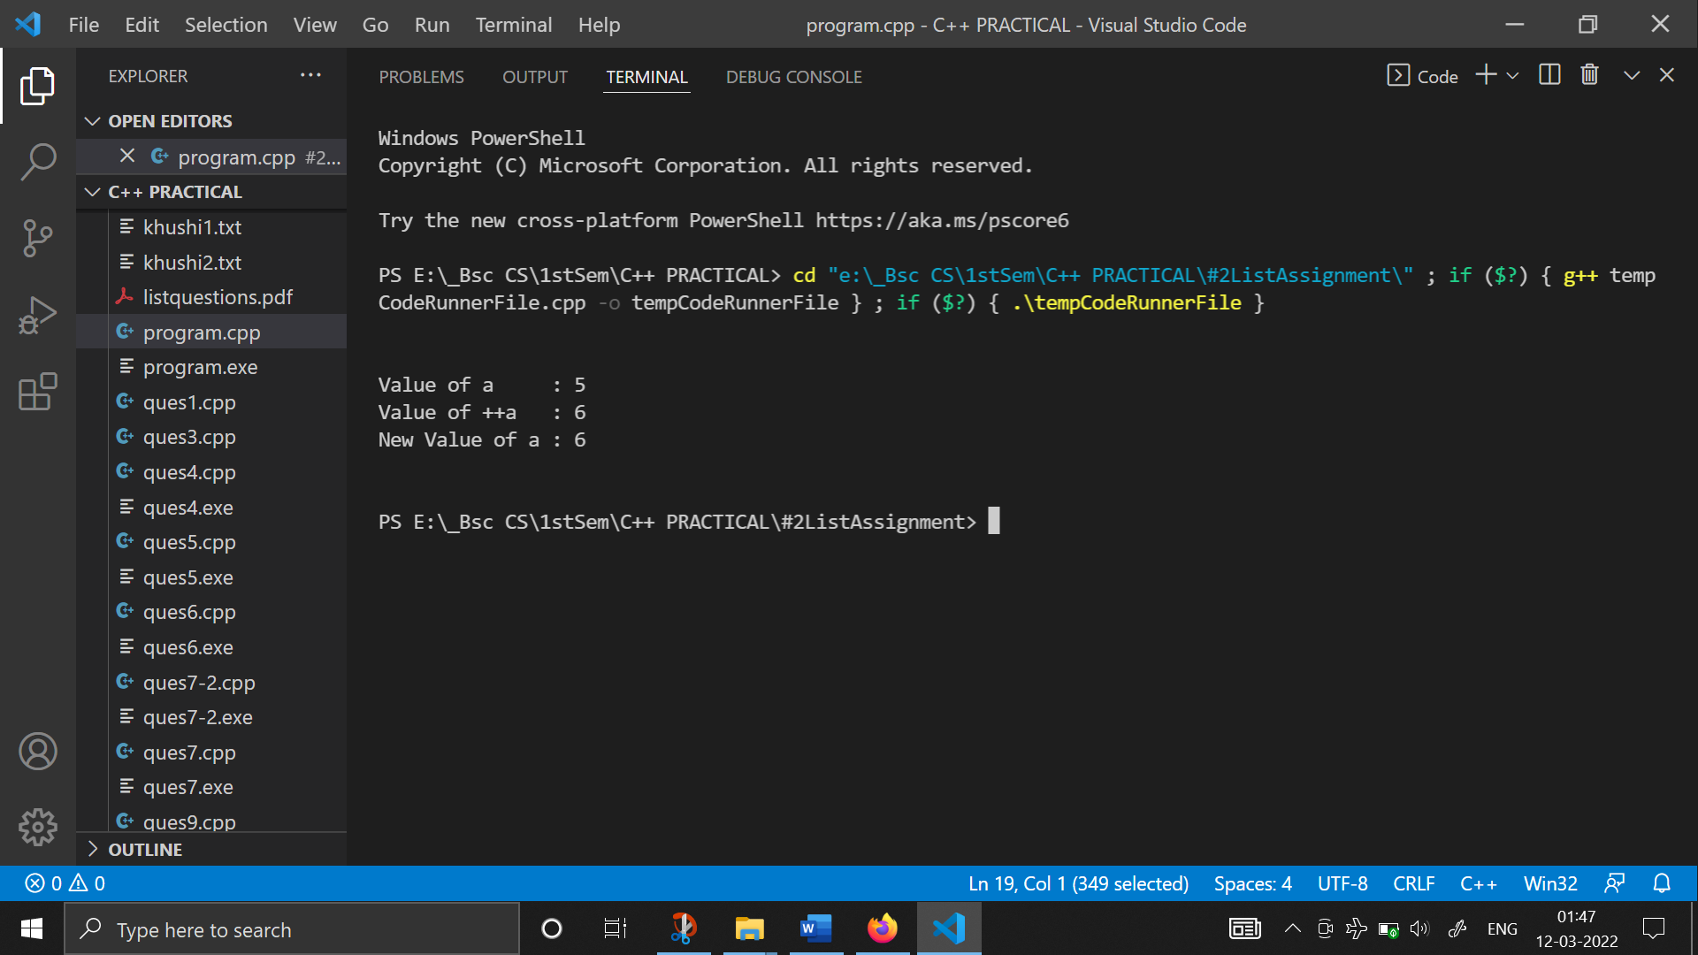

1. **WAP to demonstrate the postfix increment :**

#include <iostream>

#include <iomanip>

using namespace std;

int main()

{

    cout << endl

         << endl;

 int a=10;

    cout<< "Value of a     :"<< setw(2)<< a <<endl;

    cout<< "Value of a++   :"<< setw(2)<< a++ <<endl;

    cout<< "New Value of a :"<< setw(2)<< a<<endl;

    cout << endl

         << endl;

    return 0;

}

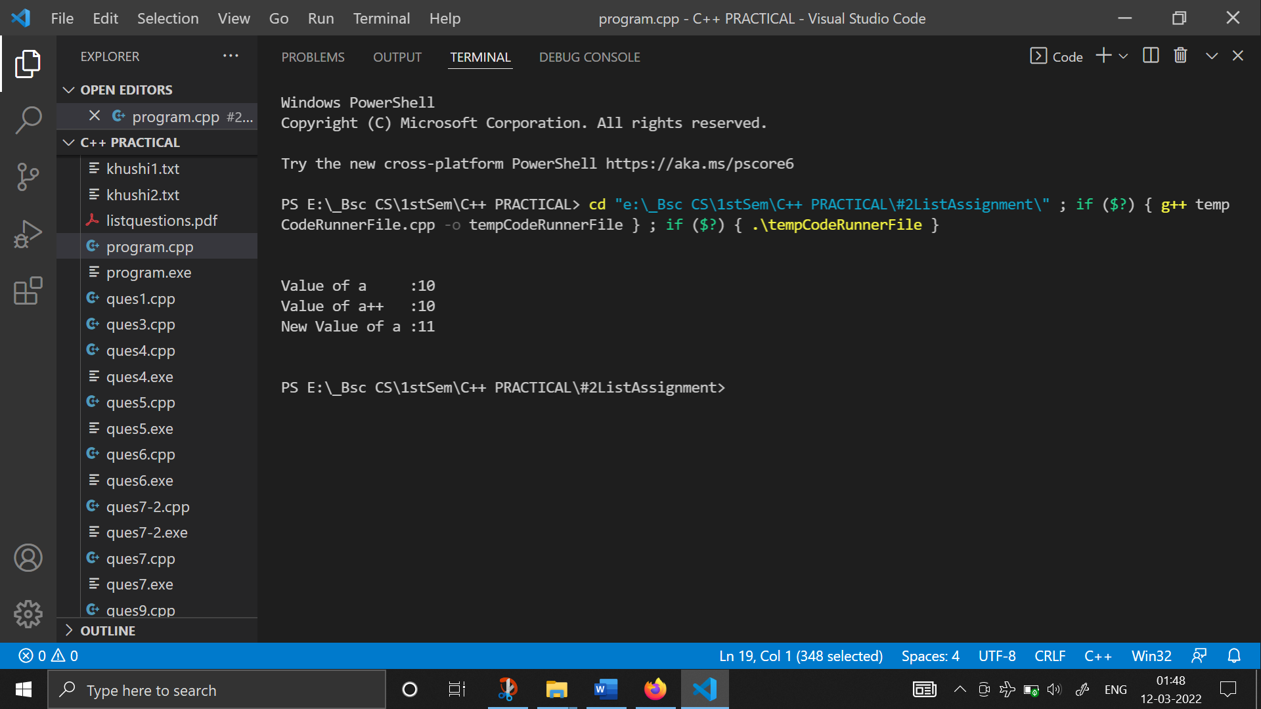

1. **WAP that examine the effect of precedence on an expression :**

#include <iostream>

#include <iomanip>

using namespace std;

int main()

{

   int a=10;

    int b=15;

    int c=20;

    cout<<"a * b + c is: "<<a*b+c<<endl;

    cout<<"a * (b + c) is: "<<a*(b+c)<<endl;

    return 0;

}

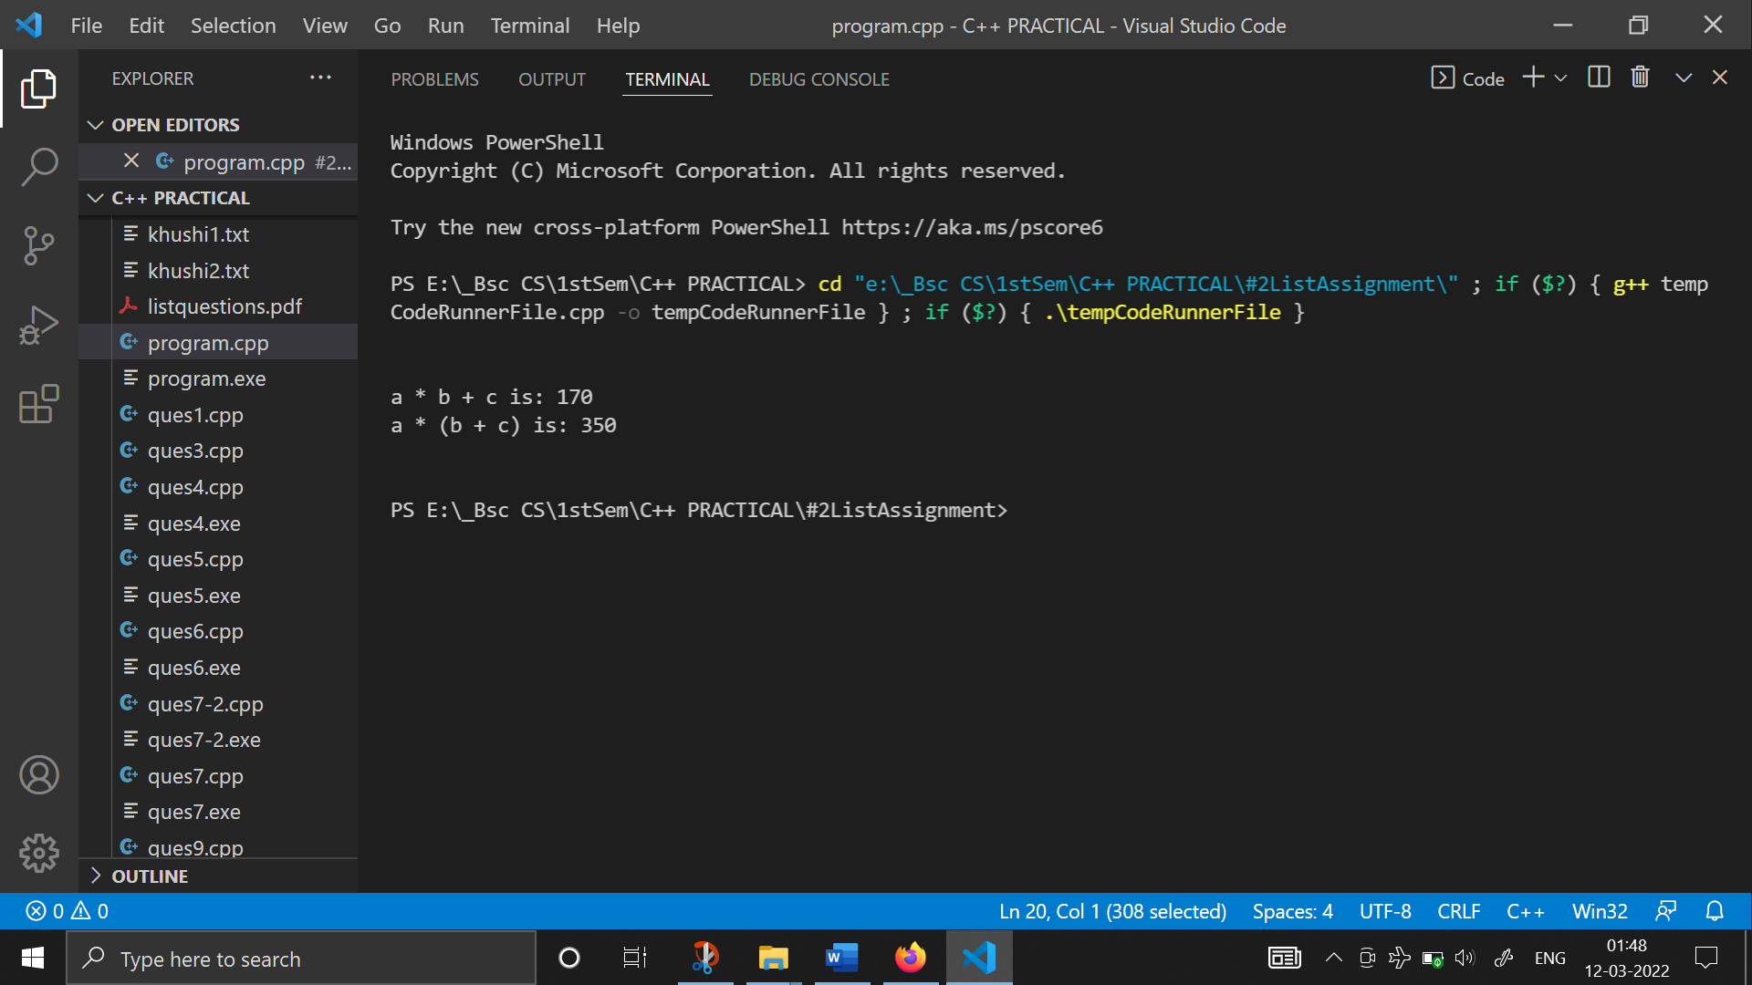

1. **WAP to check whether the given number is prime or not (without using functions):**

#include <iostream>

#include <iomanip>

using namespace std;

int main()

{

    int num;

    cout << "Enter the number: " << endl;

    cin >> num;

    int i = 2, flag = 0;

    while (i < num)

    {

        if (num % i == 0)

        {

            flag = 1;

        }

        i++;

    }

    if (flag == 1)

        cout << "Number is not prime";

    else

        cout << "Number is prime";

    return 0;

}

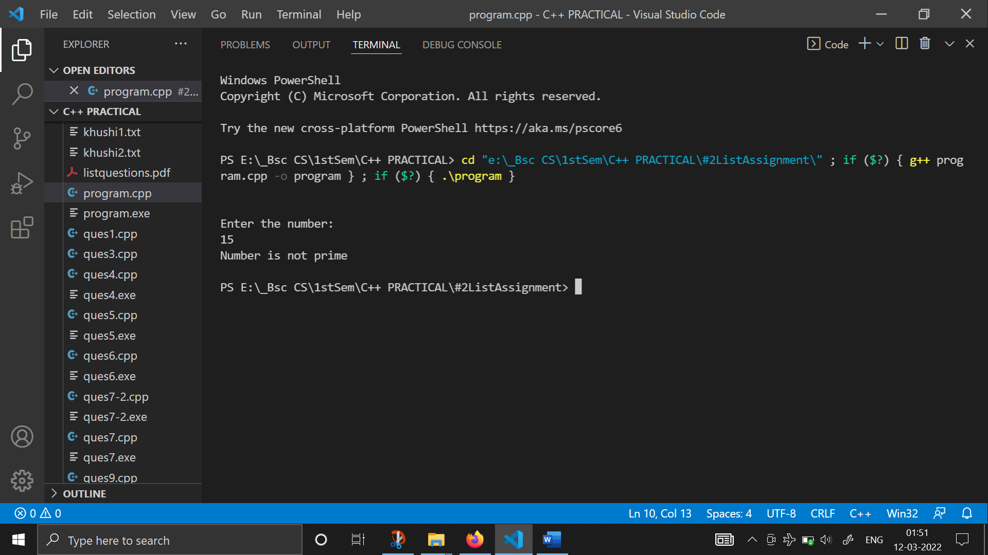

1. **WAP to check whether the given number is prime or not (using functions):**

#include <iostream>

#include <iomanip>

using namespace std;

int check_prime(int a)

{

    int c;

    for (c = 2; c <= a - 1; c++)

    {

        if (a % c == 0)

            return 0;

    }

    return 1;

}

int main()

{

    int n, flag;

    char ch1 = 'y';

    while (ch1 == 'y')

    {

        cout << ("Enter an value to check whether it is prime or not : ");

        cin >> n;

        flag = check_prime(n);

        if (flag == 1)

            cout << n << " is prime number." << endl;

        else

            cout << n << " is not prime number." << endl;

        cout << "\nDo you want to continue?(y/n): ";

        cin >> ch1;

    }

    return 0;

}

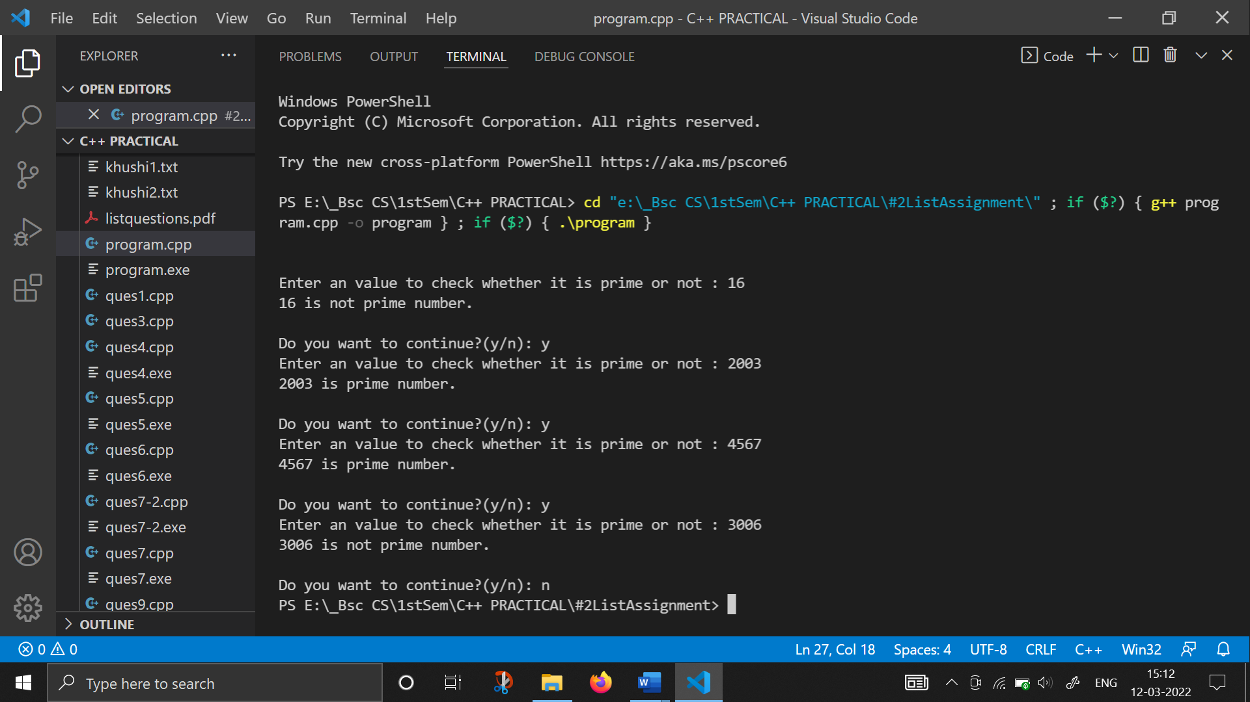

1. **WAP to create Fibonacci series (without using functions) :**

#include <iostream>

#include <iomanip>

using namespace std;

int main()

{

    int num, a1, b2, sum;

    cout << "How many terms you want to display in fibonacci series?:";

    cin >> num;

    cout << "Enter the first two terms: ";

    cin >> a1 >> b2;

    cout << a1 << " " << b2 << " ";

    int n = 3;

    while (n <= num)

    {

        sum = a1 + b2;

        cout << sum << " ";

        a1 = b2;

        b2 = sum;

        n++;

    }

    return 0;

}

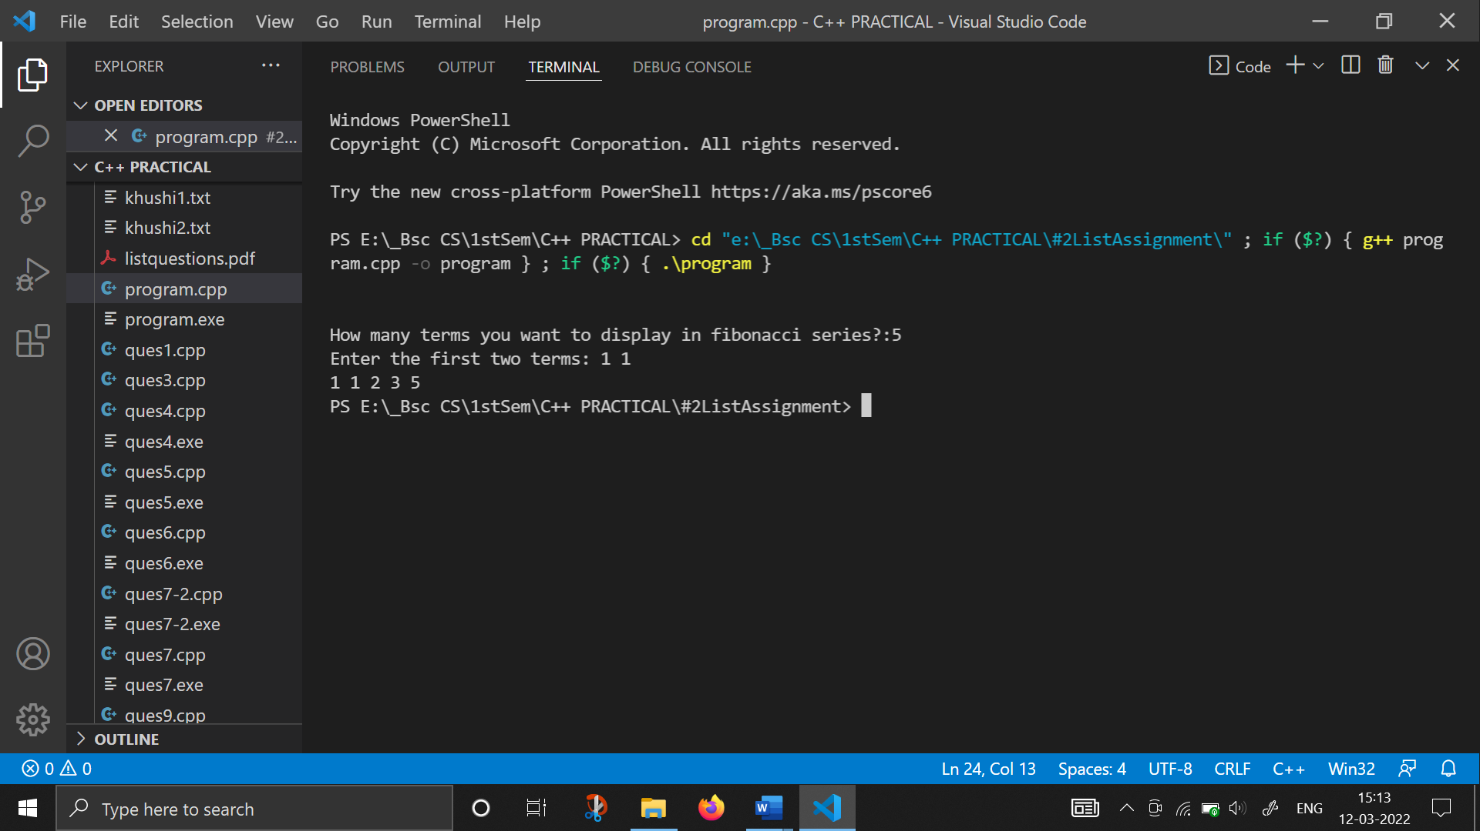

1. **WAP to create Fibonacci series (using functions) :**

#include <iostream>

#include <iomanip>

using namespace std;

void fibo(int a1, int b2, int num)

{

    int n = 3;

    while (n <= num)

    {

        int sum;

        sum = a1 + b2;

        cout << sum << " ";

        a1 = b2;

        b2 = sum;

        n++;

    }

}

int main()

{

    int num, a1, b2;

    cout << "How many terms you want to display in fibonacci series?:";

    cin >> num;

    cout << "Enter the first two terms: ";

    cin >> a1 >> b2;

    cout << a1 << " " << b2 << " ";

    fibo(a1, b2, num);

    return 0;

}

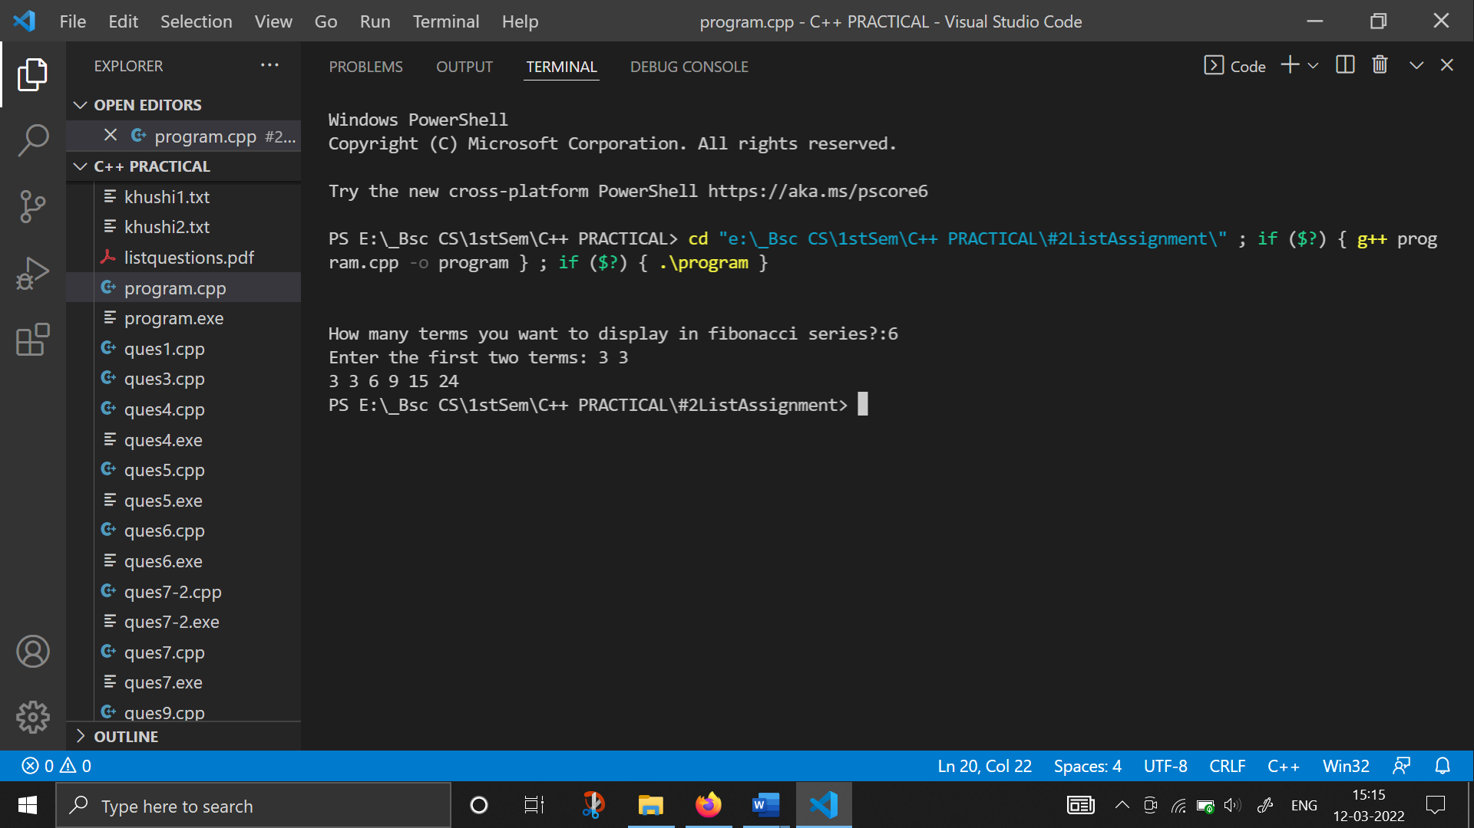

1. **WAP to find grade and percentage of student by taking 4 subject marks from the user :**

#include <iostream>

#include <iomanip>

using namespace std;

int main()

{

    cout << endl

         << endl;

    int w, x, y, z;

    cout << "Enter the 4 subjects marks: ";

    cin >> w >> x >> y >> z;

    int sum = w + x + y + z;

    float per = sum / 4.0;

    cout << fixed << showpoint << setprecision(2)

         << "Percentage: " << per << " %" << endl;

    if (per > 90)

        cout << "A++ Grade";

    else if (per < 90 && per >= 85)

        cout << "A grade";

    else if (per < 85 && per >= 75)

        cout << "B grade";

    else if (per < 75 && per >= 50)

        cout << "C grade";

    else if (per < 50 && per >= 30)

        cout << "D grade";

    else

        cout << "Fail";

    return 0;

}

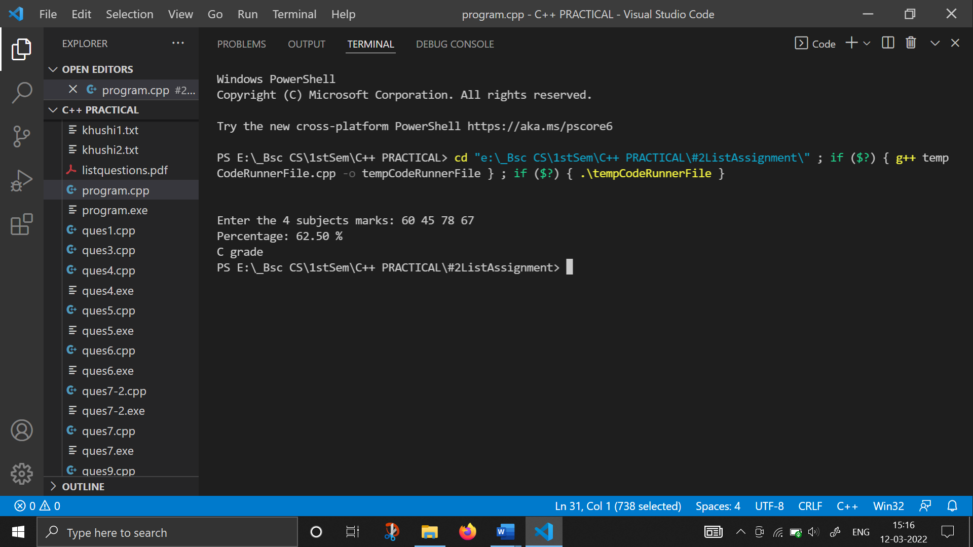

1. **WAP to find greater of two numbers entered by user :**

#include <iostream>

#include <iomanip>

using namespace std;

int main(){

    int a, b;

    cout << "Enter the 2 Values: ";

    cin >> a >> b;

    if (a > b)

        cout << "The max of two numbers is " << a << endl;

    else

        cout << "The max of two numbers is " << b << endl;

    return 0;

}

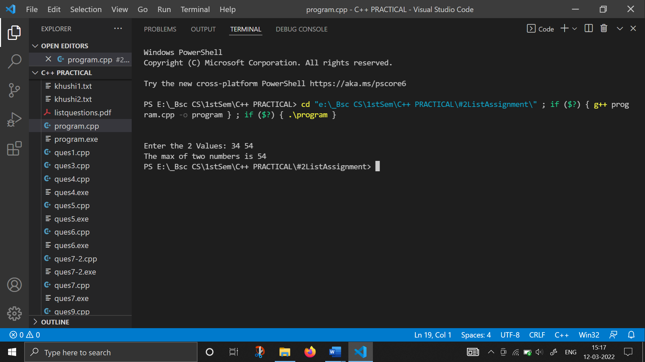

1. **WAP to find greater of three numbers entered by the user :**

#include <iostream>

#include <iomanip>

using namespace std;

int main()

{

    int a, b, c;

    cout << "Enter 3 Values: ";

    cin >> a >> b >> c;

    cout << "The Greater of " << a << " " << b << " " << c << " is: " << endl;

    if (a > b)

        if (a > c)

            cout << a;

        else

            cout << c;

    else if (b > c)

        cout << b;

    else

        cout << c;

    return 0;

}

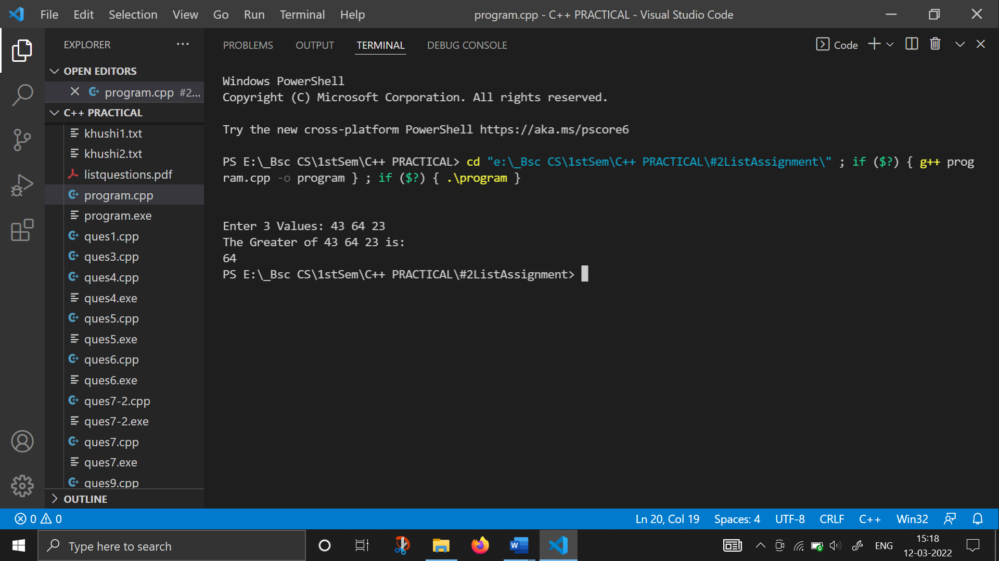

1. **WAP to find greatest of three numbers using while loop :**

#include <iostream>

#include <iomanip>

using namespace std;

int main()

{

    char ch = 'y';

    while (ch == 'y')

    {

        int a, b, c;

        cout << "Enter 3 Values: ";

        cin >> a >> b >> c;

        cout << "The Greater of " << a << " " << b << " " << c << " is: " << endl;

        if (a > b)

            if (a > c)

                cout << a;

            else

                cout << c;

        else if (b > c)

            cout << b;

        else

            cout << c;

        cout << "\nDo you want to continue y/n: ";

        cin >> ch;

    }

    return 0;

}

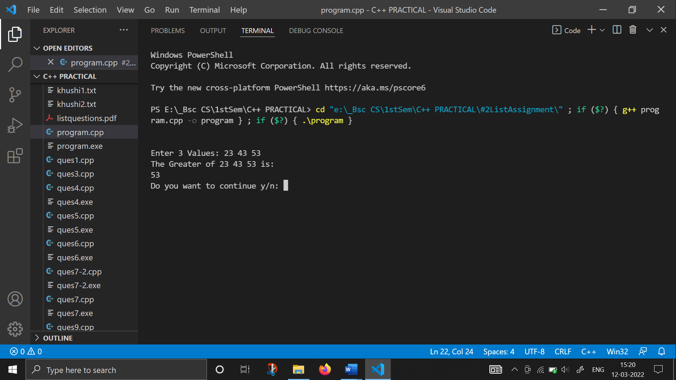

1. **WAP to find maximum numbers among the n numbers entered by the user :**

#include <iostream>

#include <iomanip>

using namespace std;

int main()

{

    int i, x, n, max;

    cout << "How many numebers you want to enter: ";

    cin >> n;

    i = 1;

    max = -1;

    while (i <= n)

    {

        cout << "Enter the " << i << " number: ";

        cin >> x;

        if (x > max)

            max = x;

        i++;

    }

    cout << "The Maximum number is " << max;

    return 0;

}

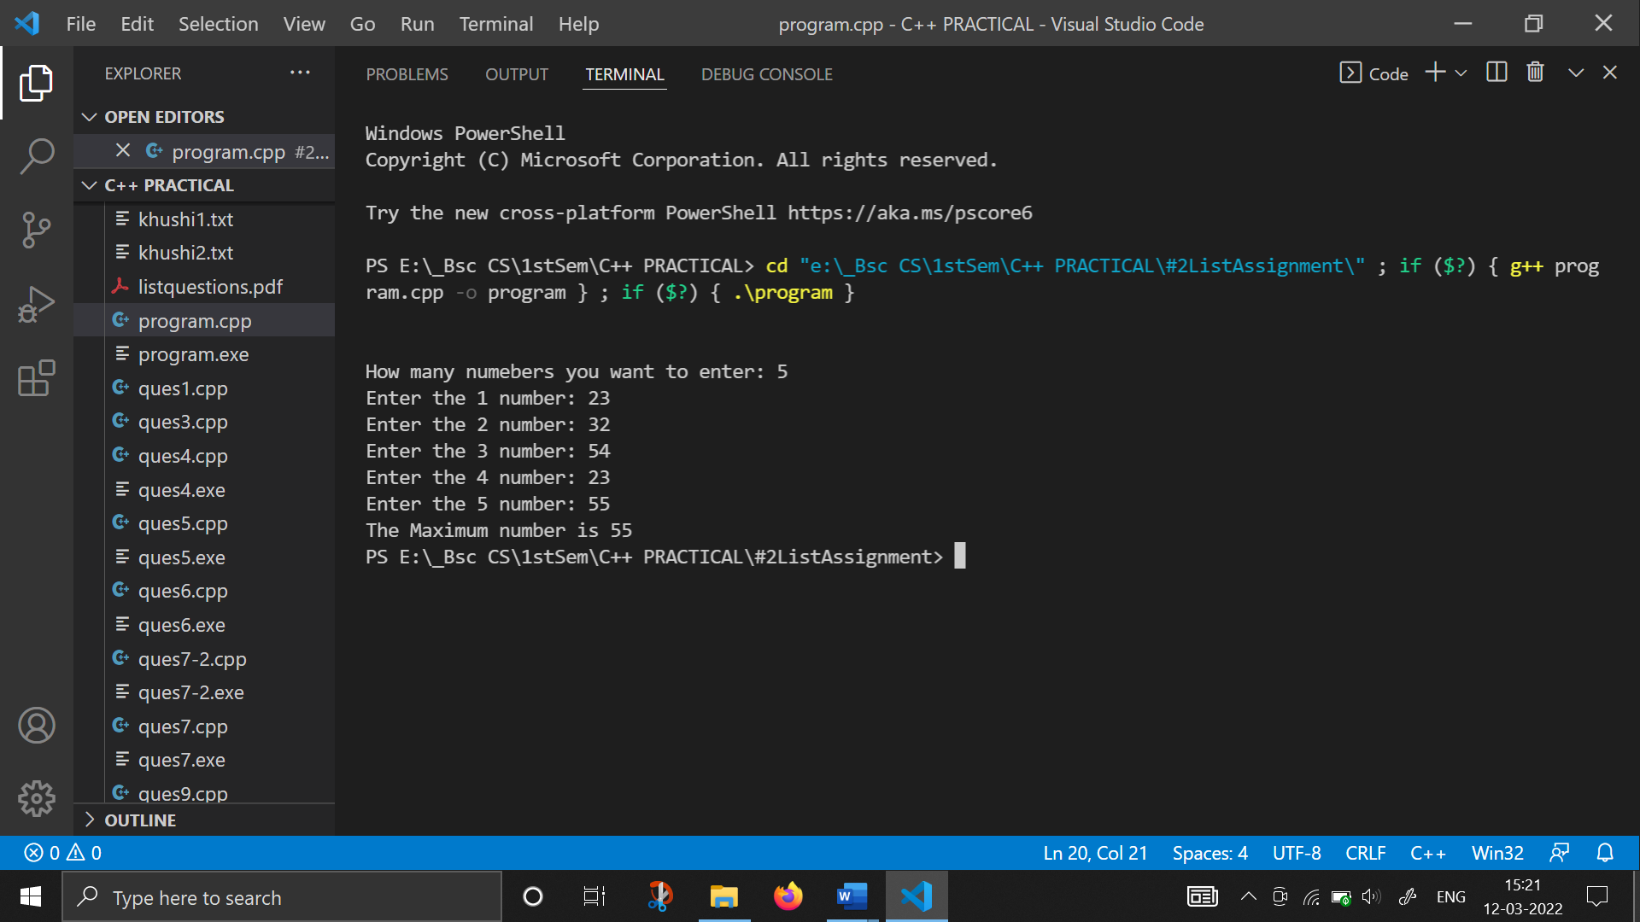

1. **WAP to find sum of even numbers in list of ‘n’ numbers :**

#include <iostream>

#include <iomanip>

using namespace std;

int main()

{

    int i, x, sum, n;

    cout << "How many numbers you want to enter: ";

    cin >> n;

    sum = 0;

    i = 1;

    while (i <= n)

    {

        cout << "Enter the " << i << " number: ";

        cin >> x;

        if (x % 2 == 0)

            sum = sum + x;

        i++;

    }

    cout << "Sum of even numbers is: " << sum;

    return 0;

}

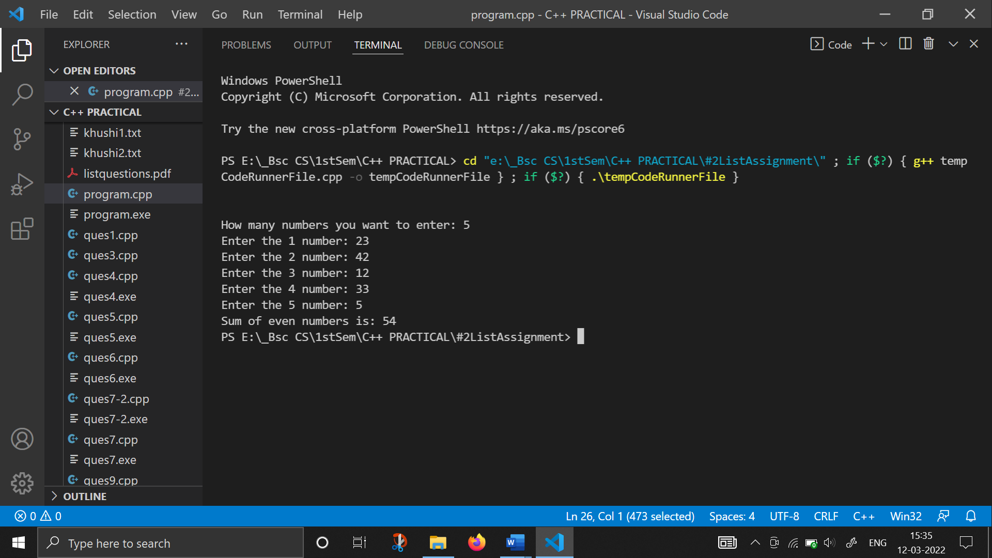

1. **WAP to display prime numbers in range of 1 to n numbers :**

#include <iostream>

#include <iomanip>

using namespace std;

int main()

{

    int i, n, flag;

    cout << "Enter the Maximum number: ";

    cin >> n;

    for (int j = 2; j <= n; j++)

    {

        flag = 0;

        for (i = 2; i < j; i++)

        {

            if (j % i == 0)

                flag = 1;

        }

        if (flag == 0)

        {

            cout << j << " "

                 << "Number is prime" << endl;

        }

    }

    return 0;

}

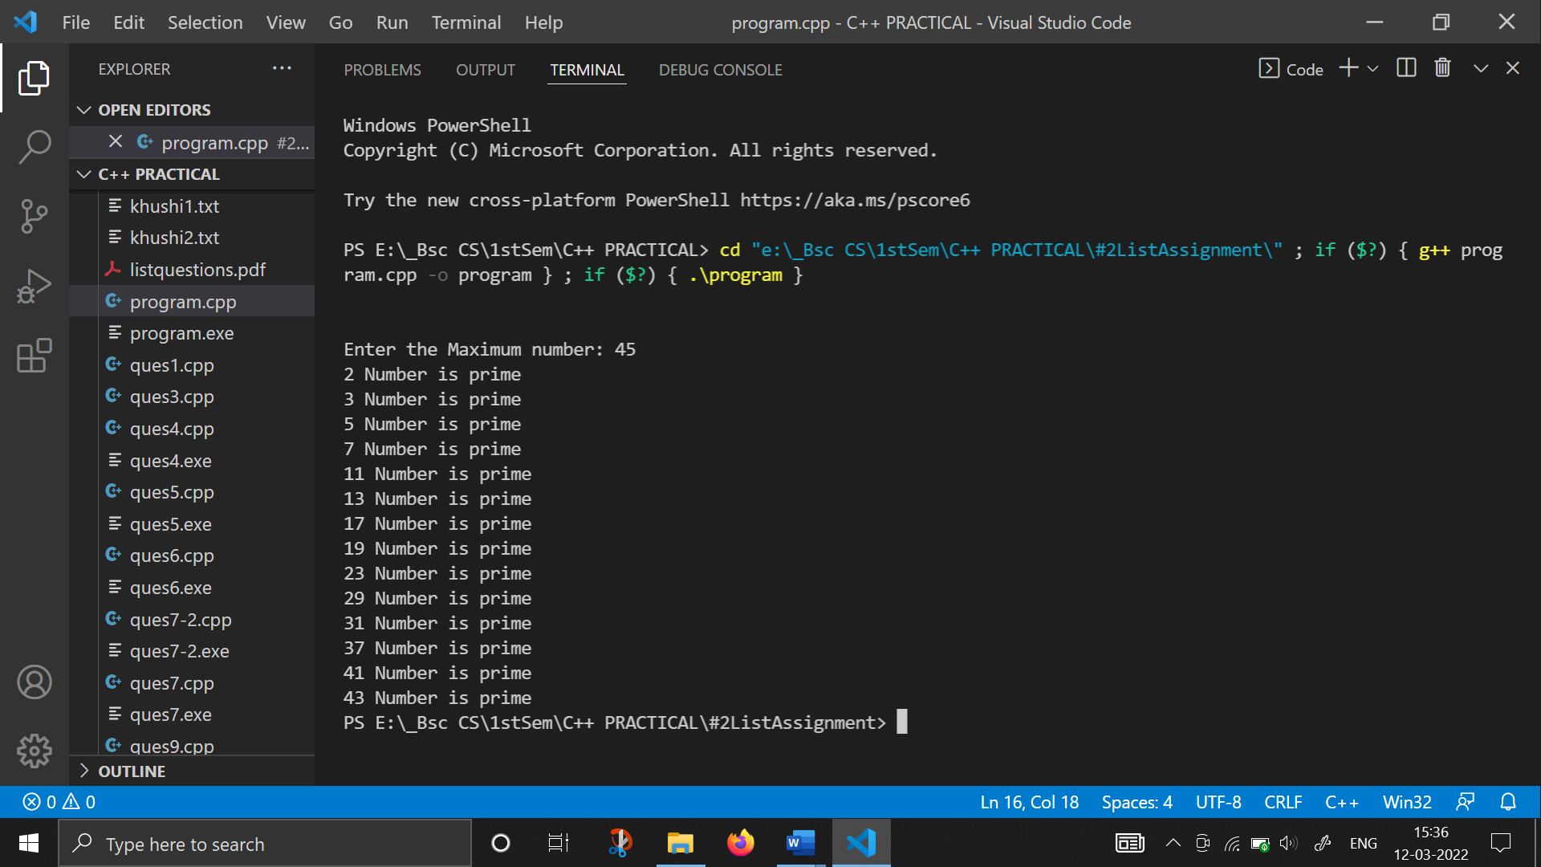

1. **WAP to display prime numbers in a list of n numbers :**

#include <iostream>

using namespace std;

int main(){

    int i, n, flag, x;

    cout << "Enter the Maximum number: ";

    cin >> n;

    for (int j = 1; j <= n; j++)

    {

        cout << "Enter the number: ";

        cin >> x;

        flag = 0;

        for (i = 2; i < x; i++)

        {

            if (x % i == 0)

                flag = 1;

        }

        if (flag == 0)

        {

            cout << x << " "

                 << "Number is prime" << endl;

        }

    }

    return 0;

}

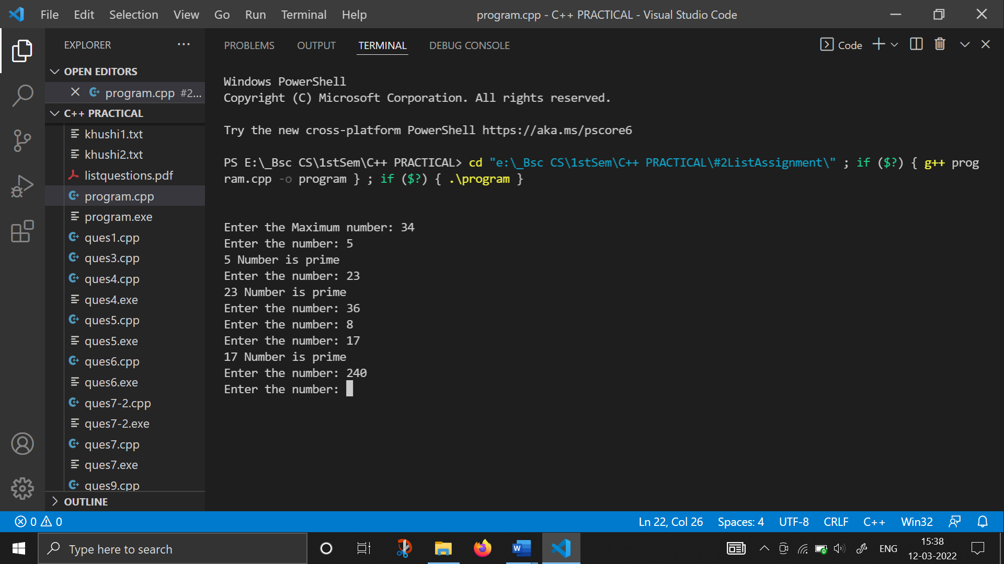

1. **WAP to print different pattern using functions :**

#include <iostream>

using namespace std;

void pattern1(int n);

void pattern2(int n);

void pattern3(int n);

void pattern4(int n);

void pattern5(int n);

void pattern6(int n);

int main()

{

    cout<<endl<<endl;

    int n, x;

    char ch1 = 'y';

    while (ch1 == 'y')

    {

        cout << "Enter your Choice: ";

        cin >> x;

        switch (x)

        {

        case 1:

            pattern1(n);

            break;

        case 2:

            pattern2(n);

            break;

        case 3:

            pattern3(n);

            break;

        case 4:

            pattern4(n);

            break;

        case 5:

            pattern5(n);

            break;

        case 6:

            pattern6(n);

            break;

        default:

            cout << "Invalid operation";

        }

    }

    cout << "\nDo you want to continue?(y/n): ";

    cin >> ch1;

    return 0;

}

void pattern1(int n)

{

    int i, j;

    cout << "Enter the number of rows you want to be printed: ";

    cin >> n;

    for (i = 1; i <= n; i++)

    {

        for (j = 1; j <= i; j++)

            cout << "*";

        cout << endl;

    }

}

void pattern2(int n)

{

    int i, j;

    cout << "Enter the number of rows you want to be printed: ";

    cin >> n;

    for (i = 1; i <= n; i++)

    {

        for (j = 1; j <= i; j++)

            cout << j << " ";

        cout << endl;

    }

}

void pattern3(int n)

{

    int i, j;

    char ch = 'A';

    cout << "Enter the number of rows you want to be printed: ";

    cin >> n;

    for (i = 1; i <= n; i++)

    {

        ch = 'A';

        for (j = 1; j <= i; j++)

            cout << ch << " ";

        ch++;

        cout << endl;

    }

}

void pattern4(int n)

{

    int i, j;

    char ch = 'A';

    cout << "Enter the number of rows you want to be printed: ";

    cin >> n;

    for (i = 1; i <= n; i++)

    {

        for (j = 1; j <= i; j++)

            cout << ch << " ";

        ch++;

        cout << endl;

    }

}

void pattern5(int n)

{

    int i, j;

    cout << "Enter the number of rows you want to be printed: ";

    cin >> n;

    for (i = n; i >= 1; i--)

    {

        for (j = 1; j <= i; j++)

            cout << "*"

                 << " ";

        cout << endl;

    }

}

void pattern6(int n)

{

    int i, j;

    cout << "Enter the number of rows you want to be printed: ";

    cin >> n;

    for (i = n; i >= 1; i--)

    {

        for (j = 1; j <= i; j++)

            cout << j << " ";

        cout << endl;

    }

}

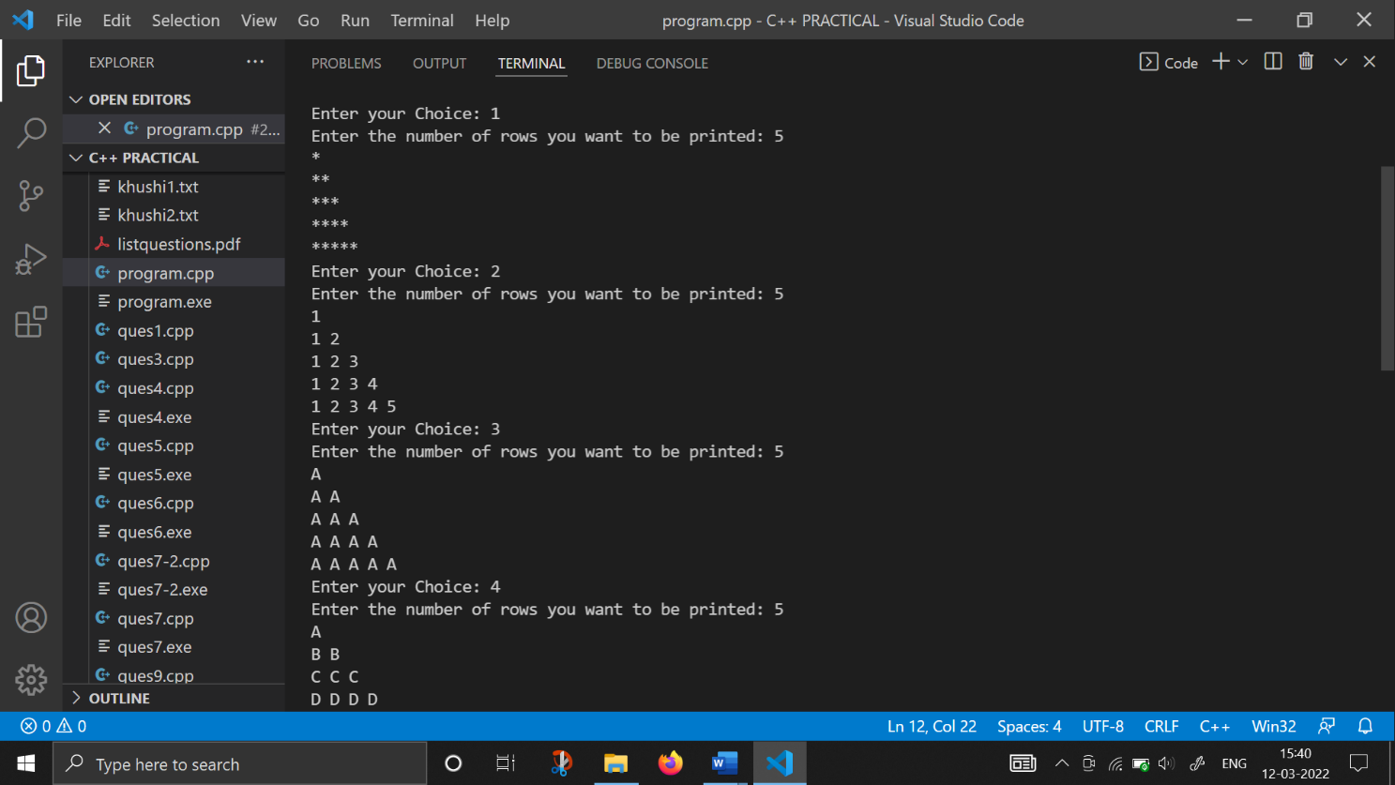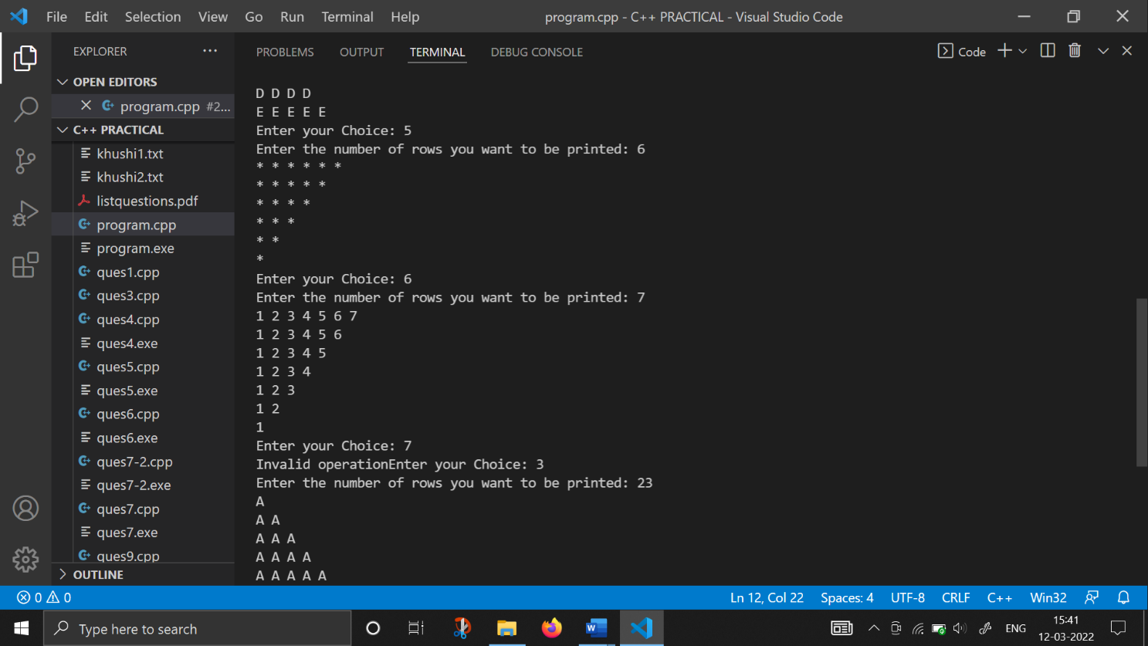

1. **WAP to print pyramid using numbers :**

#include <iostream>

using namespace std;

int main()

{

    int n, u, k;

    int j = 1;

    int max = 20;

    for (int i = 1; i <= 5; i++)

    {

        for (n = 1; n <= max; n++)

            cout << " ";

        for (k = i; k <= j; k++)

            cout << k;

        for (u = j - 1; u >= i; u--)

            cout << u;

        cout << endl;

        j += 2;

        max -= 1;

    }

    return 0;

}

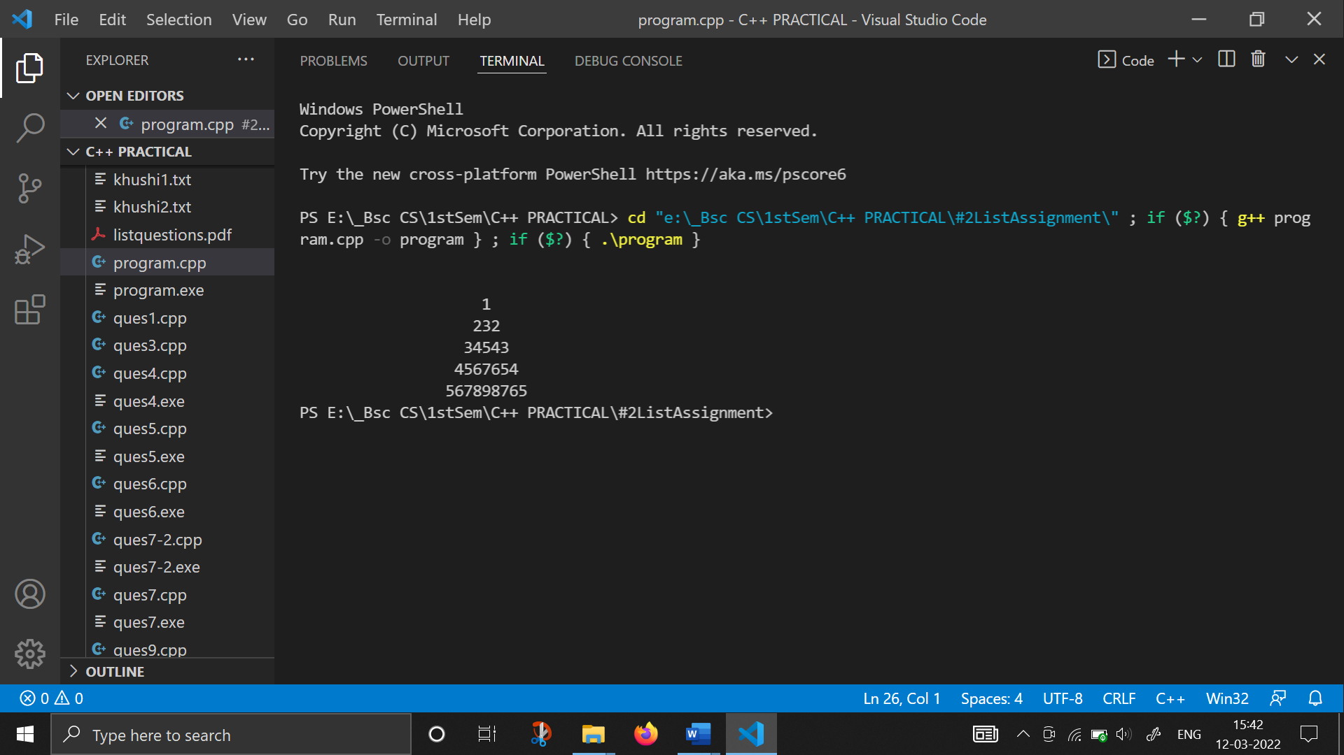

1. **WAP to print pyramid using (*) :**

#include <iostream>

using namespace std;

int main()

{

    int n,j,k;

    cout<<"Enter how many rows you want: ";

    cin>>n;

    k = 2 * n - 2;

    for (int i = 0; i < n; i++)

    {

        for (j = 0; j < k; j++)

        cout << " ";

        k = k - 1;

        for (int j = 0; j <= i; j++)

        cout << "* ";

        cout << endl;

    }

    return 0;

}

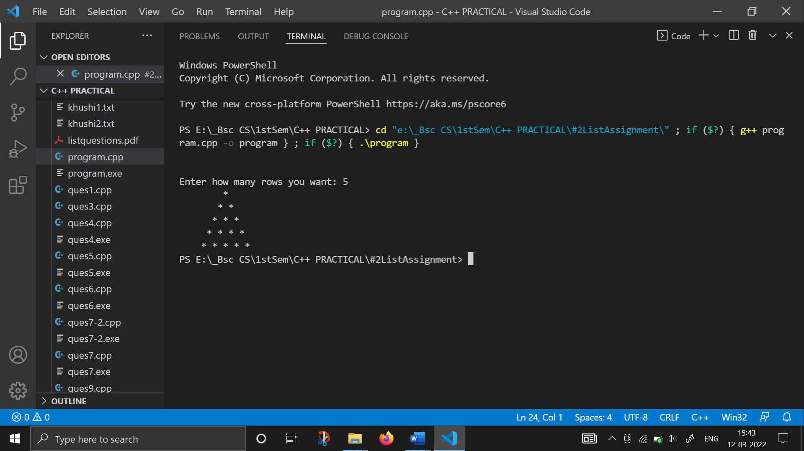

1. **WAP to print Pascal’s triangle :**

#include <iostream>

using namespace std;

int main(){

    int rows;

    cout << "Enter the number of rows : ";

    cin >> rows;

    cout << endl;

    for (int i = 0; i < rows; i++)

    {

        int val = 1;

        for (int j = 1; j < (rows - i); j++)

        {

            cout << "  ";

        }

        for (int k = 0; k <= i; k++)

        {

            cout << "  " << val;

            val = val * (i - k) / (k + 1);

        }

        cout << endl

             << endl;

    }

    cout << endl;

    return 0;

}

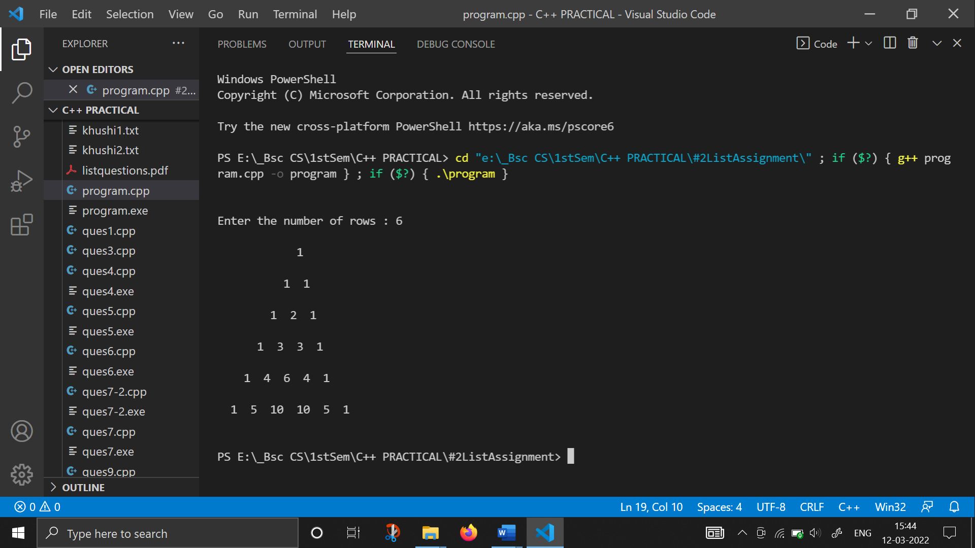

1. **WAP to perform different arithmetic operations on given values using switch case :**

#include <iostream>

#include <iomanip>

using namespace std;

int getinput()

{

    cout<<endl<<endl;

    int a;

    cout << "-> Enter a number: ";

    cin >> a;

    return a;

}

int operation(int a, int b, char ch)

{

    int z = -1;

    switch (ch)

    {

    case '+':

        z = a + b;

        break;

    case '*':

        z = a * b;

        break;

    case '/':

        z = a / b;

        break;

    case '%':

        z = a % b;

        break;

    case '-':

        if (a > b)

            z = a - b;

        else

            z = b - a;

        break;

    default:

        cout << "Invalid operation";

    }

    return z;

}

int main()

{

    int a, b, z;

    char ch, ch1;

    ch1 = 'y';

    while (ch1 == 'y')

    {

        a = getinput();

        b = getinput();

        cout << "a=" << a << setw(4) << "b=" << b;

        cout << "\n\n->Enter the operation you want to perform (+,-,/,*,%): ";

        cin >> ch;

        z = operation(a, b, ch);

        cout << "The result of " << a << ch << b << " is: " << z;

        cout << "\nDo you want to continue?(y/n): ";

        cin >> ch1;

    }

    return 0;

}

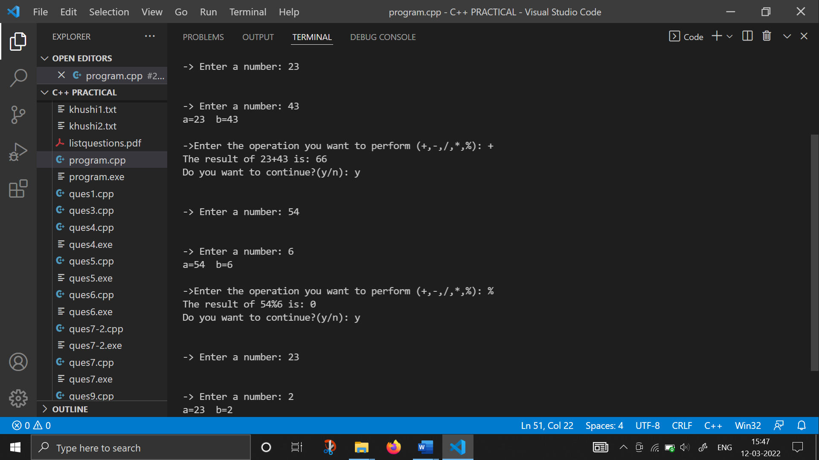

1. **WAP to differentiate btw Break and Continue :**

#include <iostream>

using namespace std;

int main()

{

    int x, n;

    n = 10;

    for (int i = 1; i <= n; i++)

    {

        cout << "Enter the number: ";

        cin >> x;

        if (x == 0)

            break;

        cout << "x=" << x << endl;

    }

    return 0;

}

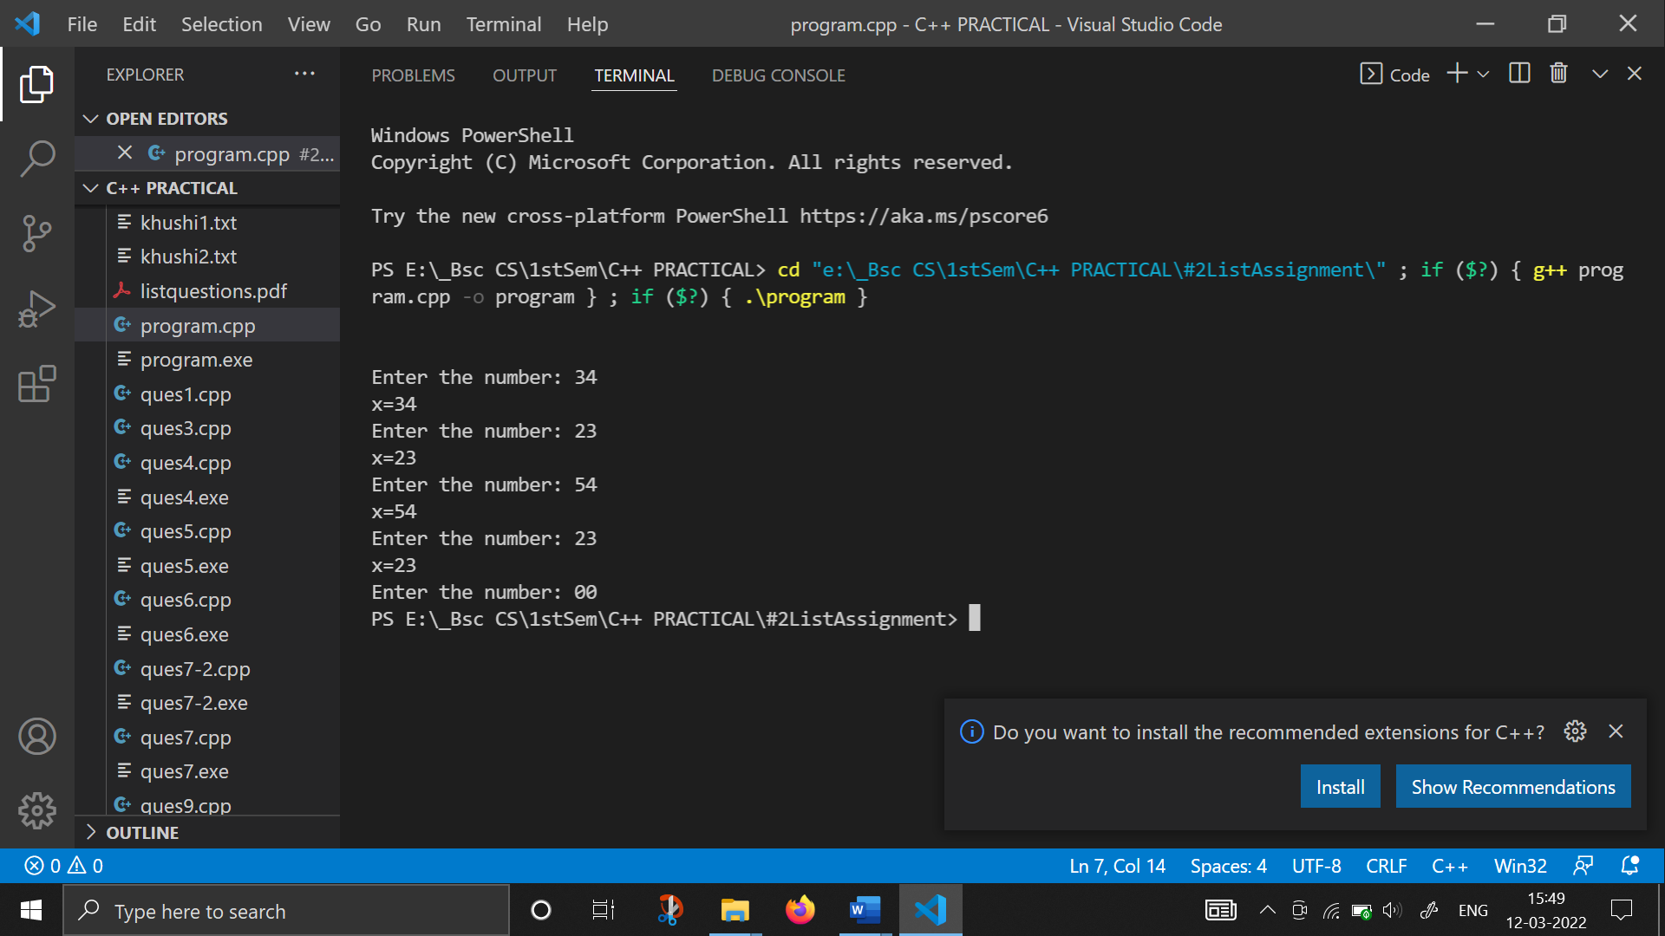

#include <iostream>

using namespace std;

int main()

{

    cout << endl

         << endl;

    int x, n;

    n = 10;

    for (int i = 1; i <= n; i++)

    {

        cout << "Enter the number: ";

        cin >> x;

        if (x == 0)

            continue;

        cout << "x=" << x << endl;

    }

    return 0;

}

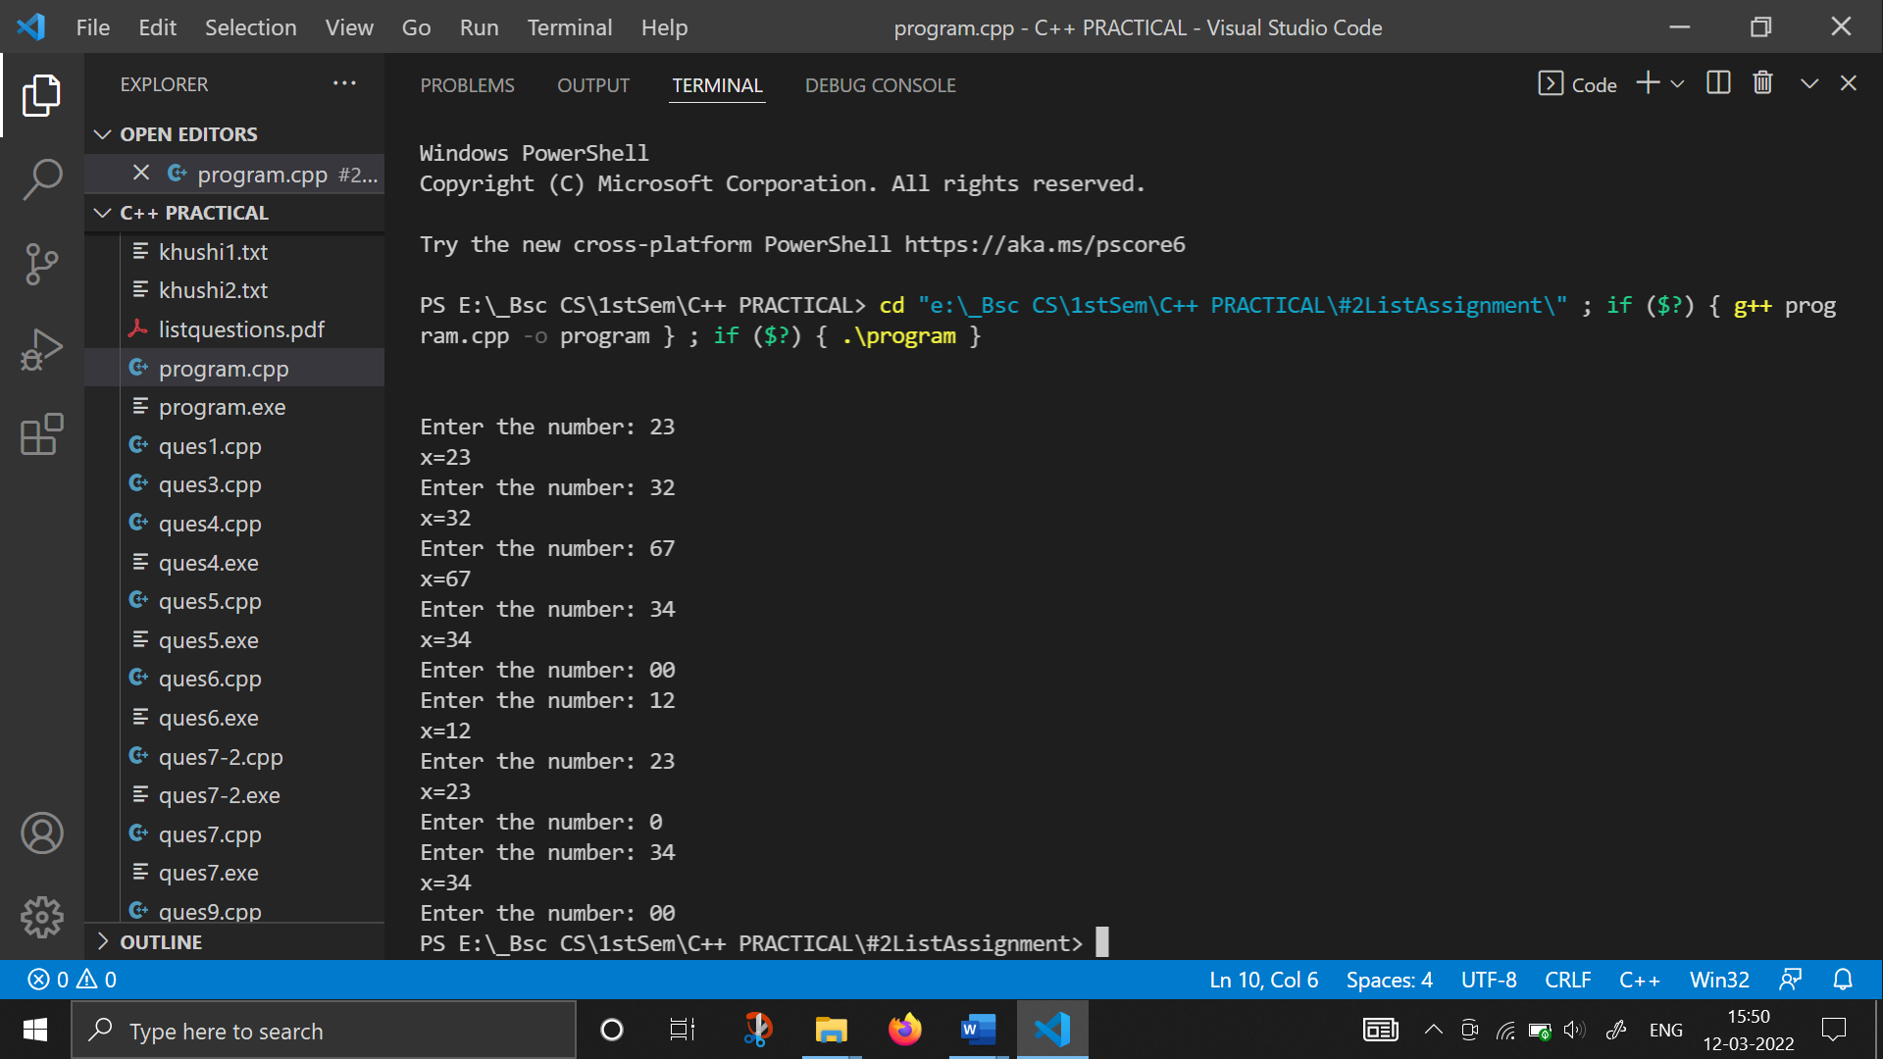

1. **WAP to store data in an array :**

#include <iostream>

using namespace std;

int main()

{

    cout << endl

         << endl;

    int arr[10];

    int x, i;

    for (i = 0; i < 10; i++)

    {

        cout << "Enter " << i << " number: ";

        cin >> x;

        arr[i] = x;

    }

    for (i = 0; i < 10; i++)

        cout << arr[i] << endl;

    return 0;

}

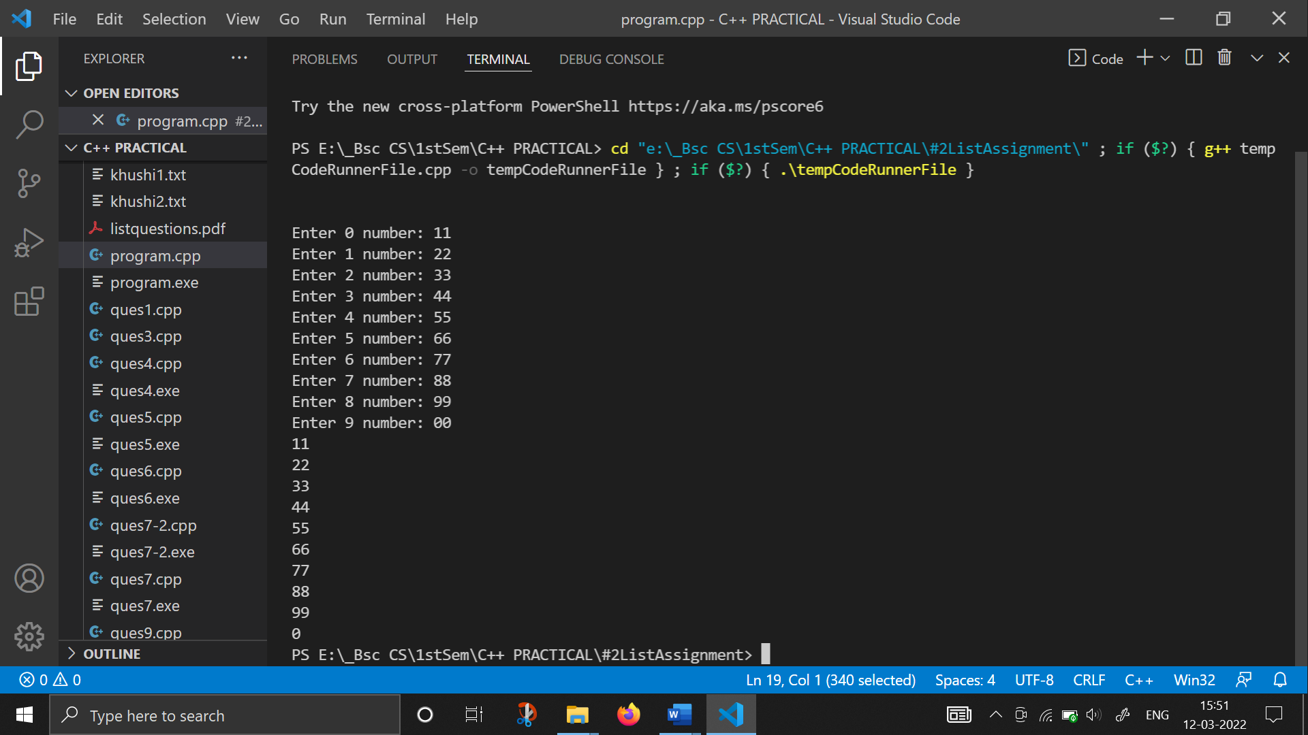

1. **WAP to find a number in an array using linear search :**

#include <iostream>

using namespace std;

void input(int a[], int n1);

void display(int a[], int n1);

void linearsearch(int a[], int n1)

{

    int i, x;

    cout << "Enter the number to be searched: ";

    cin >> x;

    for (i = 0; i < 10; i++)

    {

        if (a[i] == x)

        {

            cout << "\n\t*NUMBER FOUND*";

            break;

        }

    }

    if (i == x)

        cout << "\t*ELEMENT NOT FOUND*";

}

int main()

{

    const int n = 5;

    int arr[n];

    int x;

    char ch = 'y';

    cout << "1. Input\n";

    cout << "2. Linear Search" << endl;

    cout << "3. Display" << endl;

    while (ch = 'y')

    {

        cout << "\nEnter your choice: ";

        cin >> x;

        switch (x)

        {

        case 1:

            input(arr, n);

            break;

        case 2:

            linearsearch(arr, n);

            break;

        case 3:

            display(arr, n);

            break;

        }

    }

    cout << "\nDo you want to continue(y/n)" << endl;

    cin >> ch;

    return 0;

}

void input(int a[], int n)

{

    int i;

    for (i = 0; i < n; i++)

    {

        cout << "Enter the number: ";

        cin >> a[i];

    }

}

void display(int a[], int n)

{

    int i;

    for (i = 0; i < n; i++)

    {

        cout << a[i] << endl;

    }

}

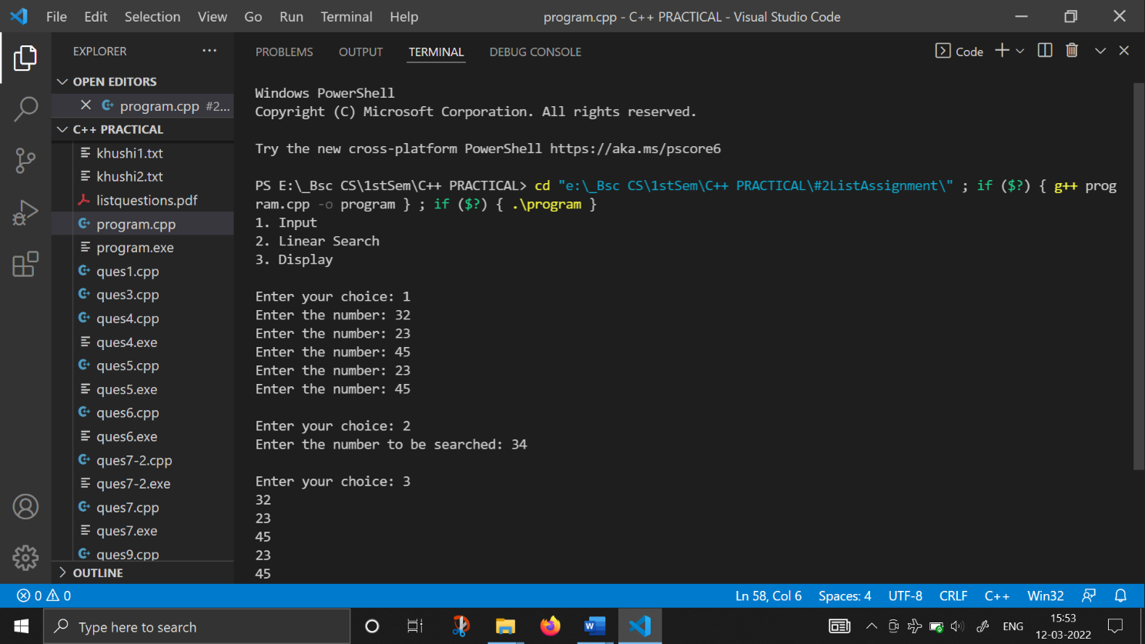

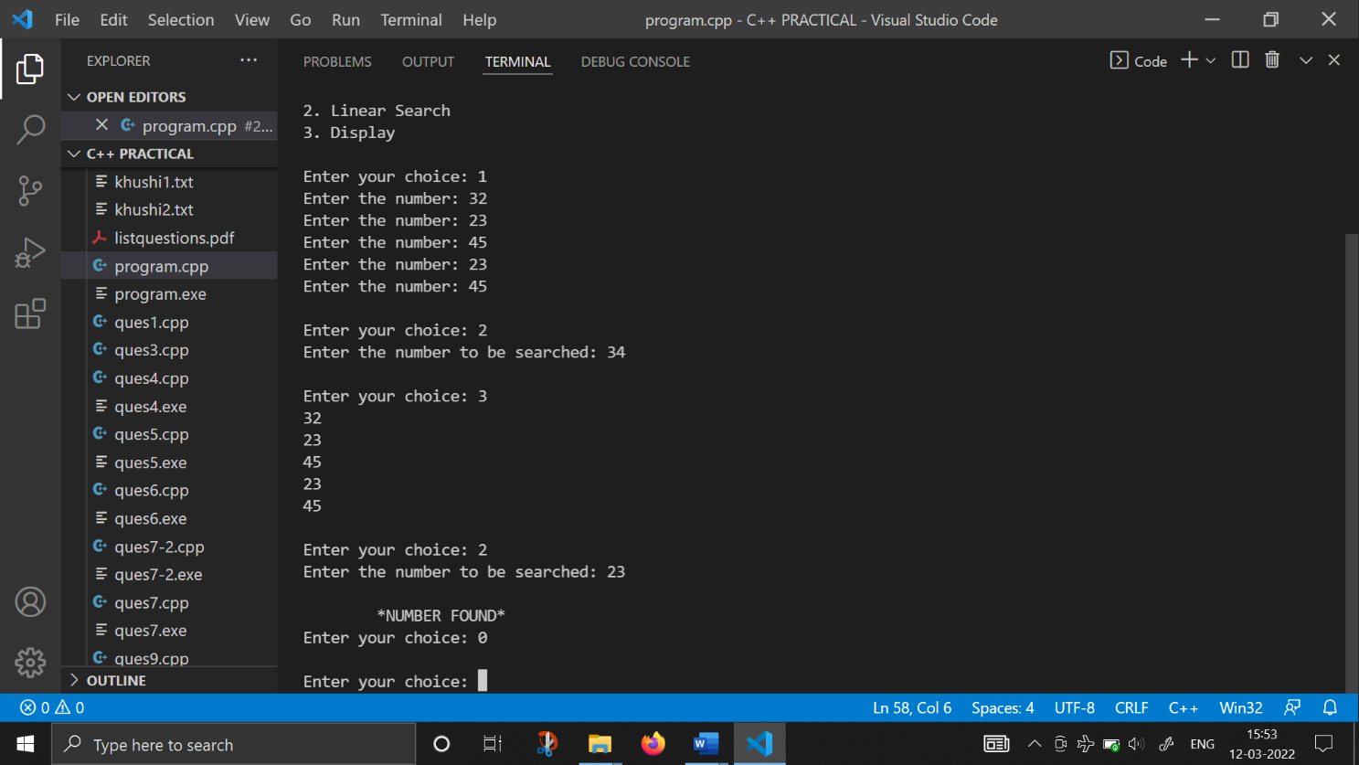

1. **WAP to find minimum and maximum elements from an array :**

#include <iostream>

using namespace std;

void getMinMax(int arr[] , int N){

   int max = arr[0], min = arr[0];

   for(int i = 1; i < N; i++){

      if(max < arr[i])

         max = arr[i];

      if(min > arr[i])

         min = arr[i];

   }

   cout<<"Maximum Value = "<<max<<"\n";

   cout<<"Minimum Value = "<<min;

}

int main(){

    const int n=6;

    int arr[n];

    int i;

    cout<<"*This Prog. find the Maximum and Minimum Elements from an array*\n";

    for(i=0;i<n;i++)

    {

        cout<<"Enter the number: ";

        cin>>arr[i];

    }

    getMinMax(arr, n);

    return 0;

}

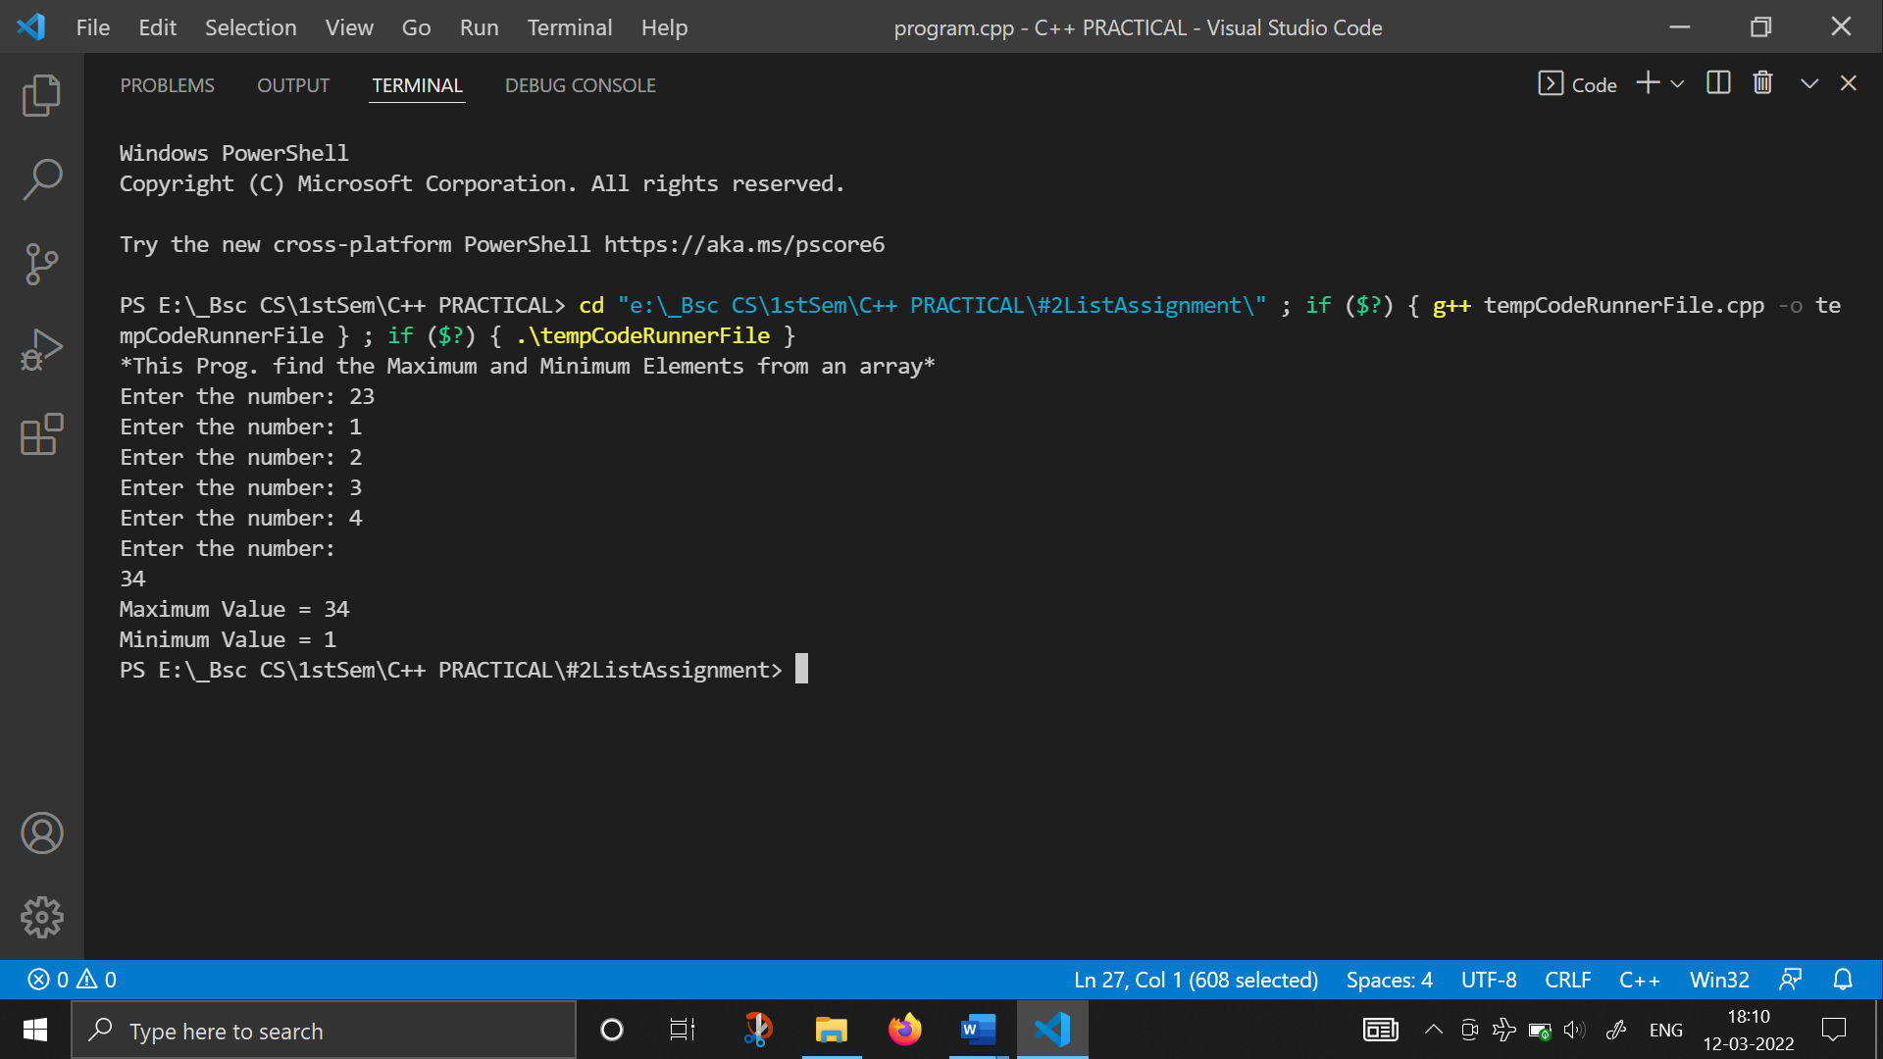

1. **WAP that reverses elements of an array :**

#include <iostream>

using namespace std;

int main()

{

    const int n=6;

    int arr[n];

    int i;

    cout<<"*This prog. will Reverse the elements of an array*\n";

    cout<<"Enter Elements of the array below:)\n";

    for(i=0;i<n;i++)

    {

        cout<<"Enter the number: ";

        cin>>arr[i];

    }

    cout<<"\nOriginal Array:\n";

    for(i=0;i<n;i++)

        cout<<arr[i]<<" ";

    cout<<"\nReverse Array:\n";

    for(i=n-1;i>=0;i--)

        cout<<arr[i]<<" ";

    cout<<endl;

    return 0;

}

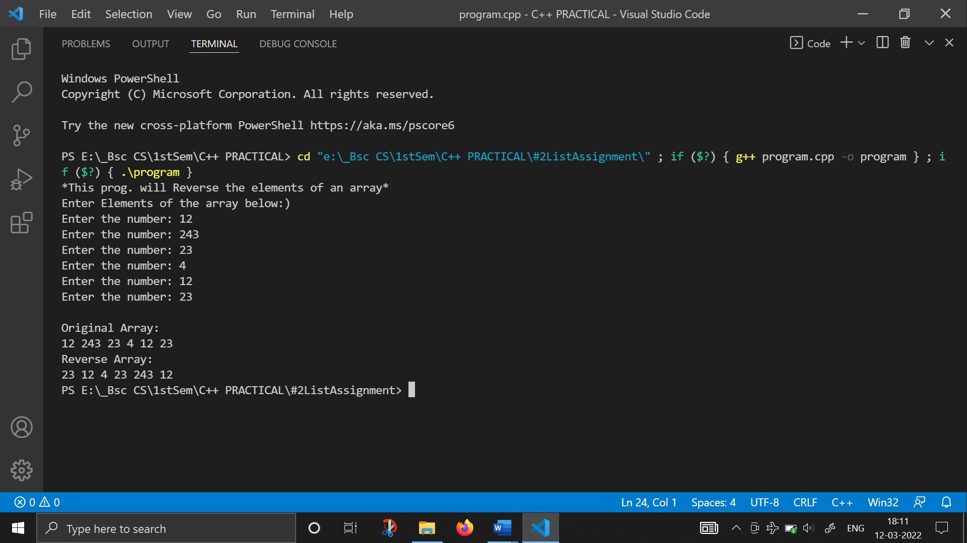

1. **WAP to perform the matrix addition using arrays :**

#include <iostream>

#include <iomanip>

using namespace std;

int main()

{

    cout << "***THIS PROG. WILL DO ADDITION USING 2D ARRAYS***";

    int a[3][3], b[3][3], c[3][3];

    cout << "\nMATRIX A" << endl;

    for (int i = 0; i < 3; i++)

    {

        cout << "Enter the elements of row of an array " << i + 1 << " :";

        for (int j = 0; j < 3; j++)

            cin >> a[i][j];

    }

    cout << "MATRIX B" << endl;

    for (int i = 0; i < 3; i++)

    {

        cout << "Enter the elements of row of an array: " << i + 1 << " :";

        for (int j = 0; j < 3; j++)

            cin >> b[i][j];

    }

    for (int i = 0; i < 3; i++)

        for (int j = 0; j < 3; j++)

            c[i][j] = a[i][j] + b[i][j];

    cout << " ---------------------------\n";

    cout << " **Elements in Matrix A**\n ";

    cout << "---------------------------\n";

    for (int i = 0; i < 3; i++)

    {

        for (int j = 0; j < 3; j++)

            cout << setw(4) << a[i][j];

        cout << "\n";

    }

    cout << endl;

    cout << " ---------------------------\n";

    cout << " **Elements in Matrix B**\n";

    cout << " ---------------------------\n";

    for (int i = 0; i < 3; i++)

    {

        for (int j = 0; j < 3; j++)

            cout << setw(4) << b[i][j];

        cout << "\n";

    }

    cout << endl;

    cout << " -----------------------------\n";

    cout << " **Addition of Above Matrixs** \n";

    cout << " -----------------------------\n";

    for (int i = 0; i < 3; i++)

    {

        for (int j = 0; j < 3; j++)

            cout << setw(4) << c[i][j];

        cout << "\n";

    }

    return 0;

}

